# Project for BUas – Personal Development Log

## Preface

This is the long, in depth version of the logs. This log contains pictures of the game, pictures and breakdowns of the code, and my personal experiences with writing the program. I don’t expect this to be fully read, as this was more of a personal thing. The other version of the logs has more concise information and is a lot more readable.

## Design concept- Frantic notation of concepts and ideas:

The first step in my design process was noting every single possible idea that came to me down, and seeing what sticks. Considering the theme of ants, the main ideas that were playing around in my head were the following:

* Something with random terrain generation, in whatever way possible. I had tackled a project like this before, but it was honestly done in a pretty tacky way (the way I did it was more Binding Of Isaac-esque, where I had a default set of rooms which I generated through a random number generator. This was done with C# and Unity, and would be very different this time around. Anyways, back on topic), and I wanted to somehow incorporate it into this project. The idea would have been some sort of randomly generated map, either a roguelike/roguelite, or some sort of survival game.
* The second idea I came up with was a puzzle game; although yes, I think pure puzzle games are quite boring and belong on mobile phones (that’s a joke, portal 2 is one of my favourite games of all time), there are some interesting concepts here; I thought of a game where a character would shoot ants out of a gun. These shot ants would form clumps of ants, which the character could walk over or use as a bridge. The character would also have a vacuum to vacuum up any additional ants or vacuum their own ants back up. Another idea for a puzzle game was a game where you controlled a colony of multiple ants, and you’d have to get through obstacle courses without losing too many ants.
* What ended up being the concept I went with was something inspired by the game “Into the Breach”, which is an isometric turn-based strategy game where you control mechs to protect cities from invading aliens. I thought; what if I turn this concept on its head and have the player control the aliens (in this case, giant ants a la the tyranids from Warhammer 40k, but more ant-like). The goal would be to destroy human (or other fantasy races, for variety’s sake) settlements/power generators, all the while fighting off humans in giant mechs (which will possibly also be inspired by Warhammer 40k, at least visually).

So, in the current concept was as follows; an isometric turn-based strategy game, where you fight an AI controlled opponent in turn-based strategy combat. The goal would be dependent on what type of mission you are playing; destroy enemy structure, kill all enemy units, etc. You control a queen and several fighter-units. The queen is your most important unit (think of the king in chess). She can create new units (up to a cap), and once she dies the game is over for you.

So, once came to the conclusion as to what concept I wanted to realize, I began thinking more of some of the details. There could be varying factions you have to take over, perhaps a human faction which has incredibly beefy wall units which you have to either break through somehow or find a way around, or a faction of elves which instead use teleportation technology to zip around the playing field, making them hard to hit. So, I concluded I wanted there to be multiple enemy factions, which pose different levels of challenge. But, realistically, I wanted to finish just one level with regular humans before I add special mechanics, factions and multiple levels.

On a more technical level, I wanted the game to have an isometric perspective, for two main reasons: one, I think it looks better, and two; It would be more of a challenge to pull off than having a regular tile set, which seems like more fun than having it just be easy.

Some (admittedly far out of scope) stretch goals would be: a random level generator, where you get a random set of enemy placements for which you get rewards, some sort of upgrade system where you can customize your own troops with different upgrades or replace them all together.

## Design concept- In summary:

### In-scope goals:

-Isometric turn-based strategy game, where you compete against an AI controlled enemy.  
-You control various units, different fighters, scouts, and a queen which can produce more units (up to a cap)  
-Different mission types: destroy cities, capture objectives, destroy all enemy units, etc

### Out-of-scope goals:

-Different types of enemy factions, which all have different powers and pose different challenges to the player  
-Upgrades to the player’s units, or different units the player can select. (different types of ants, long ranged ants vs melee ants, etc)  
-Randomly generated challenge, where you face off against a randomly generated map of enemies for rewards.

### Expected Difficulties

-Usage of C++. I’m personally more used to higher-level programming languages, such as javascript or java, so adopting C++ is going to be a bit of a struggle.  
-Implementing the enemy AI. I have never really tackled AI before (or at least not written one myself), so this will be quite difficult. I’m expecting this to be my biggest hurdle, but we’ll see.

## Development- The beginnings 06/12/2020:

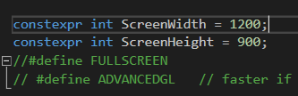First things first; frantic googling about how to approach this. I already had some experience with programming at this point (mainly web-related, but I’ve made a game in C# before so the workflow isn’t all too alien to me), but I wanted to know what I was up against. First things first; I wanted to figure out how to resize the window. This seemed like quite a challenge at first, namely because I didn’t exactly realize there was already a setting for this in the template (the screenWidth and screenHeight variables, along with the FULLSCREEN and ADVANCEDGL defines, as you can see in the picture to the right). It took me longer than I’m willing to admit to   
figure this out, I even asked around in some C++ related  
community discord servers I’m in (discord server by youtube content creator and C++ developer javidx91, a name which will surely come up more down the line).

So, I’d figured this out. There wasn’t honestly that much reason as to why I wanted the window to be a little larger, but it I figured it was too small and I wanted to implement some sort of window resizing later on too, so this was a handy thing to find this early on.

After this was finished, I wanted to create the map for the game. I want the game to be isometric; which posed quite some difficulty, considering the fact that you can’t really use a normal grid, because the screenpixels and the gridpixels don’t line up. For example; in a normal grid, 0,0 would be the top left cell. In an isometric grid, this dead in the center at the top, and it grows diagonally. Luckily, javidx9 came to the rescue with a video2 about exactly this; isometric tilemaps. There was a problem with this video however; while it properly explained the mathematics and logic behind converting a regular grid into an isometric one, he used his own library in the project. And I didn’t want to add this library to the project, so I’d have to do It on my own.

First and foremost, I needed tiles to render. A quick trip on Aseprite3 to make some incredibly simple pixel art tiles, and after about 5 minutes I was ready with a very simple tileset (seen on the left). 3 regular, basic tiles for some color variation, and one ‘selected’ tile, which I would use to indicate where the cursor was currently hovering. After this was done, I copied a little bit of the tile rendering code from the Fast Track for Games Programming4 and some modifications (making it ignore transparent pixels through a simple if-statement), and it was done! I was able to render tiles.

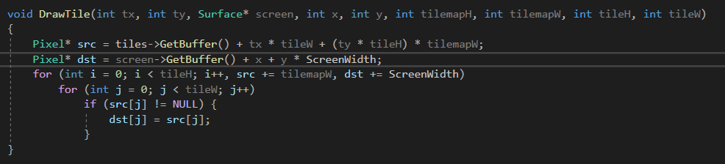

(modified tile-renderer code, which admittedly: 1. Uses a lot of parameters and 2. Is too simple for the eventual purposes, but would suffice for now)

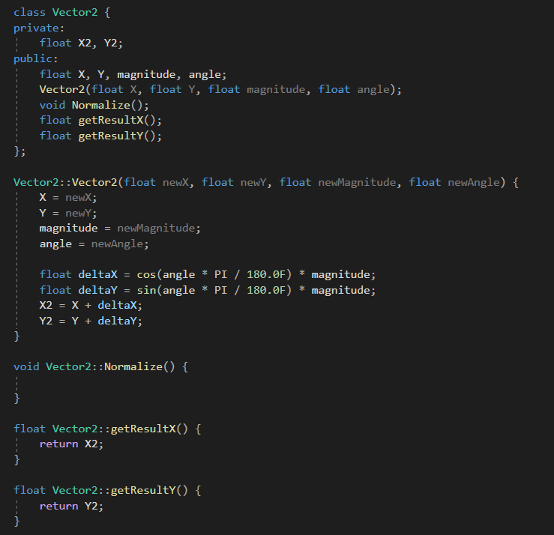Another thing was, I noticed he used vectors in his video. I don’t exactly know why, but this prompted me to create a Vector2 class, which encompassed the most basic features of a vector I knew of. Mind you, it’d been a while since I’ve done math with vectors, so a quick refresher on sine, cosine and tangent was needed5. After figuring out how classes work again (I’d forgotten, again) through the use of w3schools4, I was ready to write my vector class (seen on the right).

I did the math by myself, which surprised even me, because at this point it was about 3:30AM and my brain was starting to slowly but surely give up on itself. But, I was hard-pressed to make this work, which it eventually ended up doing.

### Sources

1Link to javidx9’s channel: <https://www.youtube.com/channel/UC-yuWVUplUJZvieEligKBkA>  
-References for learning C++/SDL2 sent by the people in his discord server:  
<https://lazyfoo.net/tutorials/SDL/index.php>  
<https://www.youtube.com/watch?v=QQzAHcojEKg&list=PLhfAbcv9cehhkG7ZQK0nfIGJC_C-wSLrx>  
<https://wiki.libsdl.org/APIByCategory>

2Javidx9’s video on isometric tilemaps: <https://www.youtube.com/watch?v=ukkbNKTgf5U&t=348s>

3Link to Aseprite on steam: <https://store.steampowered.com/app/431730/Aseprite/>

4Link to the Fast Track Part 11 about tiles where I copied and modified some code from:  
<https://www.3dgep.com/cpp-fast-track-11-tiles/>

5Reference for Sine, Cosine and Tangent calculations: <https://revisionmaths.com/gcse-maths-revision/trigonometry/sin-cos-and-tan>

## Development- 08/12/2020

I took a break on the 7th (call it procrastination or clever work division), but on the 8th I got right back into it. I continued following the tutorial I had been following1. First things first; I realized the template had a built in vector2 class; so it was time to scrap my own code. This was quite a bummer; not only had I put in quite some effort (maybe a little too much effort for what it was worth, admittedly), but this meant a good portion of the time I spent on it on the 6th was essentially just wasted. But, this led to me finally taking a proper look and understanding the template code (I’d had prior difficulties with it due to me not understanding most of the SDL2 code in there). So, at least I got something out of it.

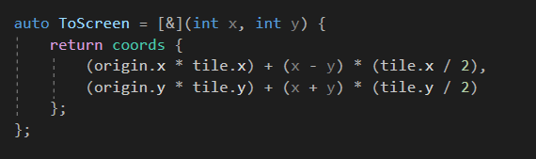Now, for the tilemap; I’d been able to render 1 tile, even a grid of tiles, but there was a problem; this grid was only a grid in screen-space. So it didn’t properly look like a 3D square, as it should. So I had to make a separation between world and screen space, and a conversion method to do so. First things first was the arithmetic required for this; to generate a new properly next to the previous tile from an isometric perspective, I had to first get the tile height and width (which in my case was 32 by 64 pixels). Then, when generating a new tile, I had to offset it by half the tile width and height, in order for it to appear properly next to the previous tile. So, code-wise, the first step was to set up some necessary variables; I set up 3 main vectors which I would use to generate the world with; ‘world’ which held the size of the world, ‘tile’ which held the size of the tiles in pixels, and origin, which dictated the start of the generated world map in coordinates. So, next on the chopping board was to actually convert the world-coordinates to on screen coordinates; I did this with a small lambda function which took the world-coordinates, and calculated the screen coordinates accordingly. (seen on the right).

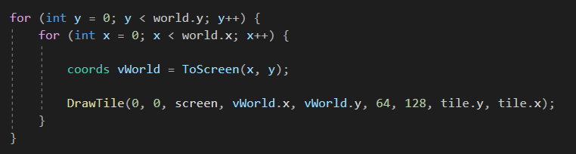As you can see, it takes the coordinates of the worldspace (x and y), and turns them into on-screen coordinates as follows: It first adds the offset on the screen determined by our origin-coordinate. So in this case, the map would be generated starting at about the middle of the screen. Once the offset 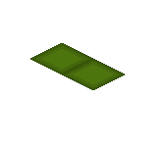is added, it adds the offset for the tile to be generated correctly; take the x coordinate for example. Say, you increase your x coordinate by one. That would imply the tile generates a bit below and to the right of the tile (as seen to the right), more specifically it generates with exactly half of the tile’s width and height as an increment. After doing this with both the x and y factors (using addition with the y values because they have to be displayed to the left instead), and sure enough, after running the generation code in a loop we had our full map.

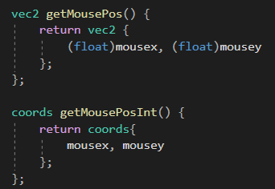Above the loop in which it is generated. It generates the on screen coordinates from the world coordinates, and then draws the tile accordingly. What you might have noticed is that I am not using the vec2 that’s included in the template, instead using a struct called ‘coords’. The reason why is fairly simple; the vec2 class uses floats, while most of these values (the values of the world coordinates, for example), are integers. Rather than fiddling around with conversions which take time and memory, I made a quick struct called coords containing only two integers, namely X and Y, and used that for everything instead.

Now, for the tile selection; selecting a tile normally was fairly simple, I just had to check which tile the cursor was hovering over, and draw a ‘selection’ tile over it. This was done through adding the methods seen to the left to the Game-function, which would return the mouse position, either in floats using vec2 or in integers using coords. Although, this posed a problem; it was selecting the tiles in screenspace. What this meant is that, essentially, it only covered the tiles that occupied full screen coordinates, and not the ones in between. In essence: It only selected half of the tiles. Now, There would be two solutions for this; I calculate whether the cursor is located outside of the main tile through some complex math, or, as the video proposed, I use a different method;   
Using the tile seen on the right, using the offset of the tiles, I do something very simple; I check the color of the pixel in this image based on the location of the cursor within the tile. If I’m in the top left of the file, this would read a red pixel from the tile to the right, which would signify that I’m on a halfway tile. All that was left was adding this for every side, and then incrementing either the x or y coordinate with 1 based on what side it’s on.

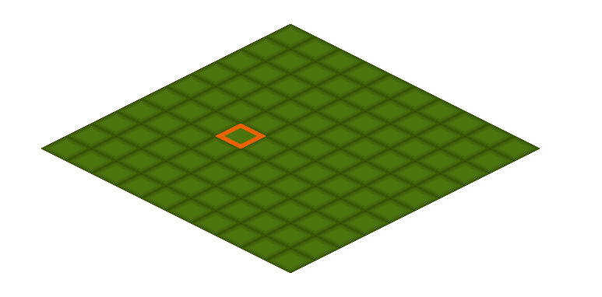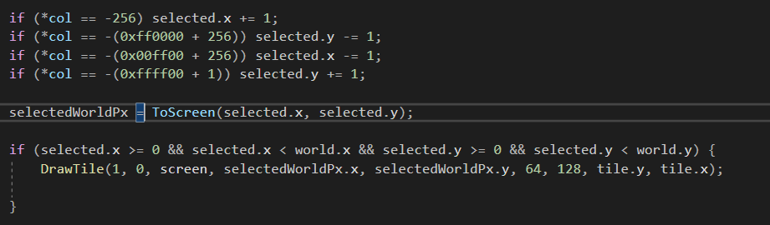above the code for this incrementation of the world coordinates based on the colour of the tiles. I added 256 or 1 to the code here and there and turned the values negative, because it didn’t exactly match with the colours on the tile (I was able to get the colours of the tile by reading them out and printing them to console).

Above is the complete tilemap with a single selected tile. On the next page is the complete code for the generation of this map. (I did a few texture changes to make things look a tad cleaner, as the previous tiles looked kind of bad.)

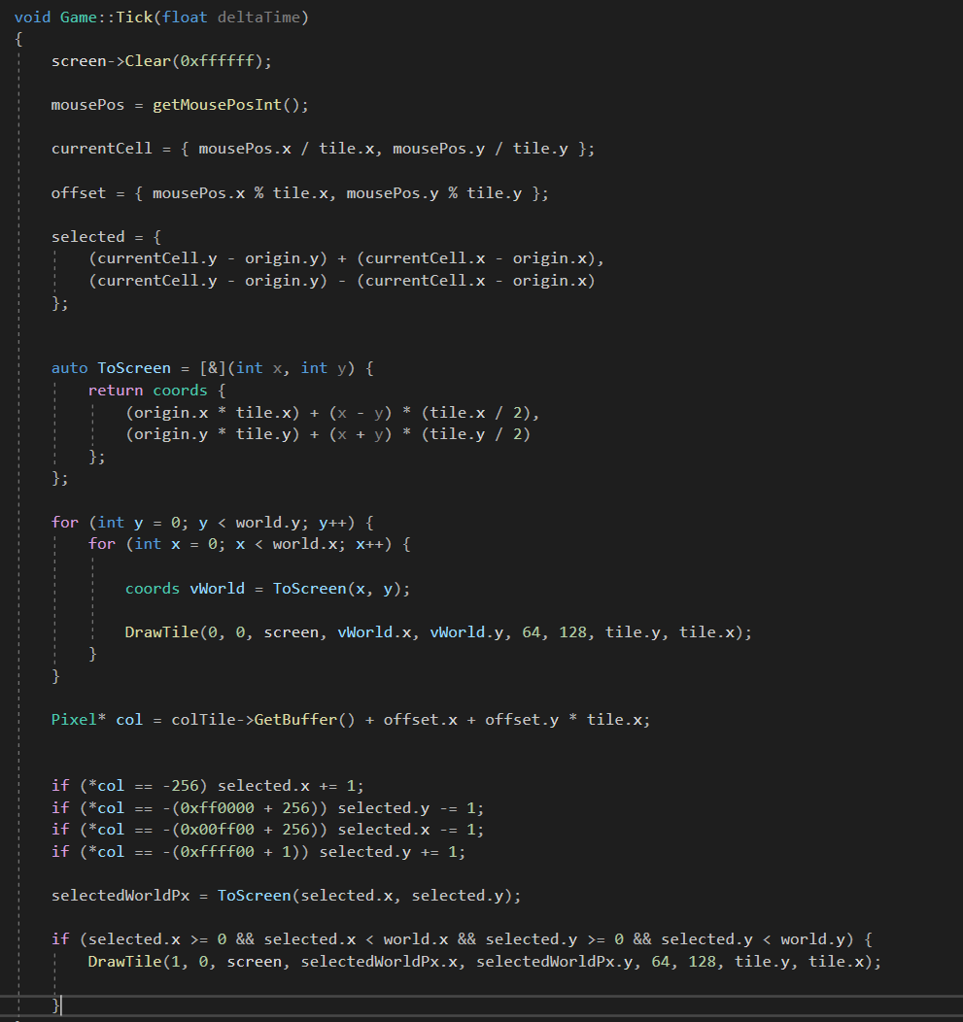Above is the entire code for the generation of this tilemap. A few unexplained parts are

* GetMousePosInt() is a method I added to get the value of the cursor position in integers
* currentCell is the current cell the cursor is in in screenspace
* offset is where in the current cell the cursor is located

After this I limited where the selection tile could appear so it only appeared on the map to prevent the program from crashing once I went out of screen space with the cursor, and there we had it; a perfectly functional tile selection process. Next to do was the interaction with the tiles through clicking, but that would be for a later date since it was around 3AM again and I had work the next day.

## Development- 16/12/2020:

At this point, there had been a lot of small changed I’d made over the ~10 days that had passed, but overall I hadn’t been as productive as I would’ve liked. While this was due to various school- and work obligations, procrastination also definitely played a part in it. But, to recap;

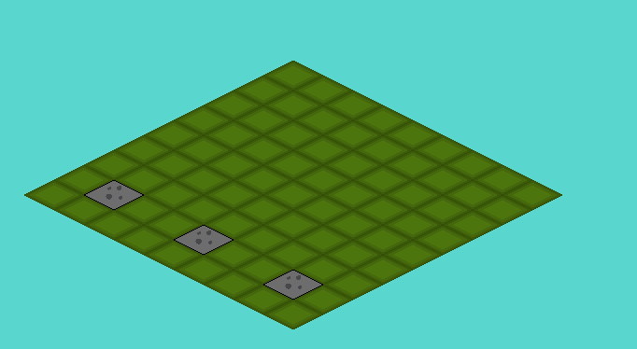I had created a ‘unit’ class, which holds all the data a unit needs (well, at this point it didn’t, because I wasn’t finished with writing it). I struggled a lot with figuring out the header file, where the main problem I faced was as follows; I want access the “drawTile” function (which had now been renamed to draw()) from the ‘Unit’ class in the header file. I tried moving drawTile(), but this would give errors since it used various parameters of datatypes the header file didn’t recognize (Surface, Pixel). Even when implementing them I encountered errors. After trying for what felt like hours, I decided to do some googling. I found various1 sources concerning the topic, and one thing quickly became clear to me; I shouldn’t have even been trying to do this, seeing as the draw() function would have to exist in game.cpp anyways, so there was no use declaring it again in game.h. So, with this out of the way, I finished up the Unit class and created 3 units that would be placed on the board. (Units seen below, represented by the gray tiles for now).

(Code for the unit class on the next page)

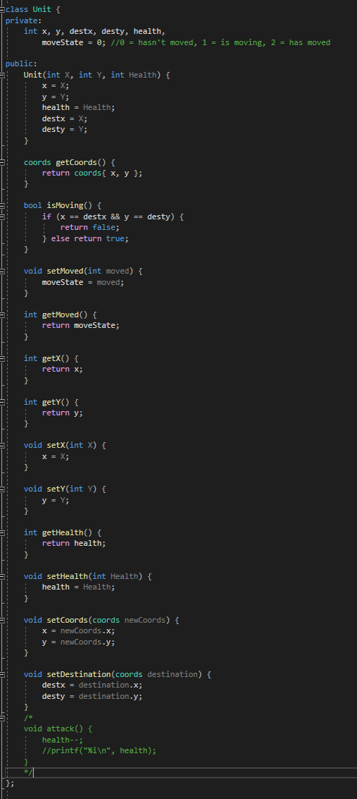Let’s go over what was included in the Unit class at this point (this point being, the final rendition for this session, as I didn’t really log much of the previous renditions, which, admittedly, was stupid of me.); for attributes, it had:

* x – current X coordinate on the field
* y – current Y coordinate on the field
* destx – X destination for moving
* desty – Y destination for moving  
  (I will go more into moving later on)
* health – total health of the unit
* moveState – the state of movement, I will go deeper into this later.

I declared an array of 3 friendly units, which all held coordinates for where they would be placed down. Once they were placed down, I needed to somehow find a way to move them. I dove into this, admittedly, way too quickly without considering the logic behind it. I started out by looking how to register mousepresses, which I found in the template. There was a slight problem I faced; the mousepress had to interact with variables stored in the main file itself, so it couldn’t just be a method. I solved this in an admittedly roundabout way, a real brute-force solution, but it served its purpose for now. What I did is; I declared a function prototype in the header file, which the method would then call when the mouse was pressed, and which would then be declared further in the game.cpp file to use the variables stored there.

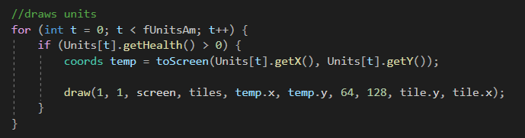Now, once it registered mouseclicks, moving it was fairly simple; by changing the x or the y coordinates of the unit directly, it would move to the new x or y coordinates. Fairly simple stuff (also seen in the draw command below with which I drew the array of units). This would loop over the array and draw each unit individually, at their respective coordinates.

So, to test some things, at first I had the x-coordinate increase by 1 whenever the button was pressed. I used the same selection method as I used earlier to indicate hovered tiles, and used the currently selected variables to check if the cursor was hovering over a unit. 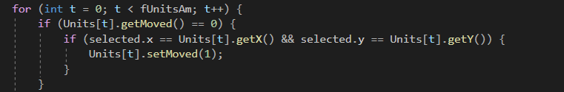

Above is included in the function doSomething(), which is called on mouseclick. It compares the selected tile to the coordinates of the Units, and moves them by 1 on the X axis when clicked on. So, this worked for now, I was able to move the units along the X axis when I clicked on them. Great. But this was the point where I actually started thinking about the general flow of the game. So, to break it down, the gameflow I came up with goes as follows:

* Player starts their turn in a move-phase, where they get to move their units anywhere on the field.
* The player moves their units by first clicking on the unit he wants to move.
* The player then selects a tile the unit should move to, depending on whether the unit can actually move there. The units themselves will function kind of like chess pieces, with different movesets, e.g. some can move straight forwards, others can only move diagonally, etc. For now, the units are only going to be movable straight forwards in one of 4 directions.
* Once the desired tile is clicked, the unit moves there by increments, as if to play a walking animation.
* Once the unit arrived at its destination, it can no longer move any more.
* Once all units have moved, the player enters an attacking phase and can attack with their units.
* This attacking phase will follow the same principal; the player clicks their units, and then selects a direction for their attack to take place in. The units or objectives in the selected tiles then take X amount of damage.
* Then the enemy takes their turn.

So, not only did I realize that this project would be immensely more complex than I initially gave it credit for, but now I had to figure out how the player would move their units using increments. First things first; to establish a turn-flow, I added an integer variable called turnSate. The value of this variable would determine where the game currently is; 0 being movement phase, 1 being attacking phase, etc. Now, once this was in place, I added some more things. I added a button to the right of the field, which would change the state of the game manually. I intended to keep this button for the player to manually skip his turn. 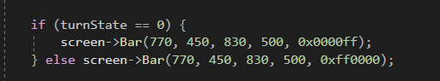

Here is the code to generate the button; nothing fancy, just a bar that is red when in the attacking phase and blue in any other phase (there were no other phases at this point).

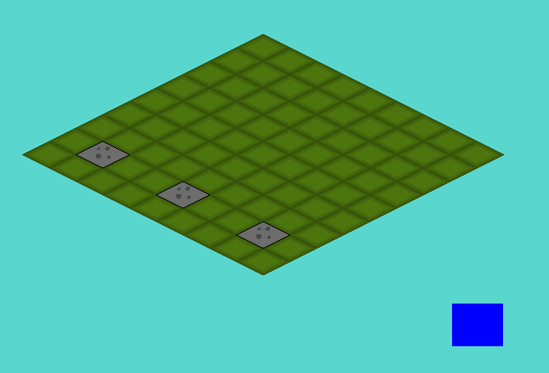

Above the field, with the button included.

Once this was implemented, I could go and work on the actual movement of the units. First things first, this was the point where I added the “destx” and “desty” variables, instead of changing the x and y variables directly as I had previously been doing. I also added the moveState variable, which would indicate in what stage of movement the unit currently is; 0 meaning the unit hasn’t moved, 1 being the unit is currently moving, and 2 meaning the unit has moved and can’t move anymore.

Now, there were a few things I had to make sure;

* The player shouldn’t be able to move his units to a spot occupied by another unit
* The units should move over time, e.g.: 4 fields per second, to indicate a sense of movement rather than teleportation.
* The units shouldn’t be able to move when another unit is moving
* The units should have a max range to travel to, which should be indicated when clicked on them.

Now, the first problem on this list I tackled was the units moving over time. I had been able to make units move, and making them move over time required a little change in how I handled it. While previously I had just made the units increment whenever the player clicked, or had them teleport once the player had selected the new position, now I had to increment them over time. This was actually surprisingly easy, all I did was add the aforementioned ‘destx’ and ‘desty’ variables, which would create a destination for these units to go to. So, now I could do another thing; I could check if a unit is in the process of moving by checking if the current coordinates and the destination coordinates were the same or not. If they were; the unit wasn’t moving. If they weren’t; the unit was moving and no other unit should be able to move. 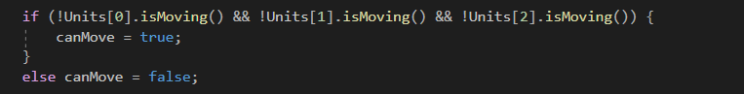

Above is the code that checked whether all the units are moving or not. If they aren’t, the canMove Boolean would be set to true, indicating a new unit can move and vice versa.

So, now all that was left was to add the code to increment the position of the units over time, towards their destination. This wasn’t hard at all; I had the destination coordinates and the current coordinates, so all that was left for the units to be able to move properly was to put a move function in the game::tick method, do some calculations and voila! There it was, the perfectly functioning move phase (Although, it still didn’t account for obstacles such as other units, nor did it have a max range yet, but those limitations would be for later). 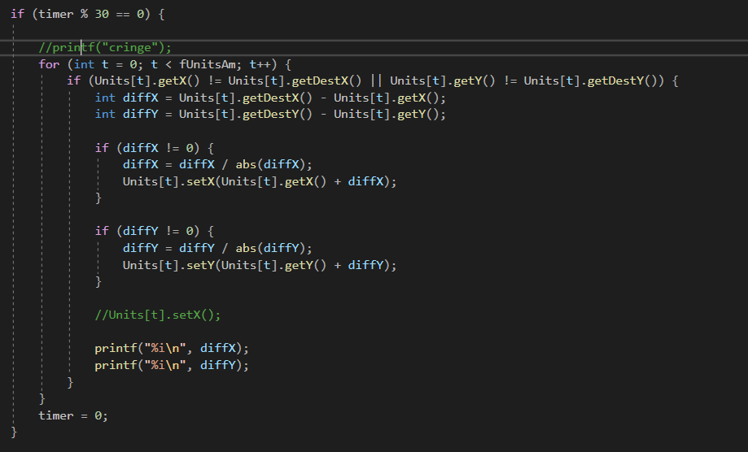

Through using a timer which would increment by 1 on every tick, checking if the modulus when divided by 30 (this could also be 60, 20, or any other whole number depending on how fast the units should move), and resetting it afterwards to avoid possible future errors concerning integer overflows, we can make this code execute twice a second (60 ticks a second, every 30 ticks the code executes = 2 times a second). The math here is also fairly simple, we get the difference between the current X and Y coordinates and the destination X and Y coordinates, divide it by its absolute value to get a value with a range of [1, -1], and make sure there is an exception for when the value is 0 to avoid division by 0 errors. And, there it was; functional movement! At this point I felt satisfied enough for me to get some sleep, as it was again around 3:00AM.

1Sources about header files:  
<https://stackoverflow.com/questions/25274312/is-it-a-good-practice-to-define-c-functions-inside-header-files>  
<https://stackoverflow.com/questions/16313174/c-cannot-i-assign-values-to-a-variable-in-header-file>  
<https://stackoverflow.com/questions/38942013/declaring-variables-in-header-files-c/38942057>

There weren’t much resources this time around, as most of the coding was me fiddling around without really looking anything up.

### Reflection

I was definitely unproductive these last 10 days. While work and school certainly played a role, I didn’t work on this project as hard as I ought to have over these last few days, and I intend to change that. I also made a large error not looking into how the game would flow, and instead wanting to make the units move so early without properly thinking about it. It could’ve saved me a lot of unnecessary work and time if I had just sat down and thought about it.

Additionally, I struggled a lot with figuring out what exactly should go in the header file and what shouldn’t. I eventually figured it out (although I’m still not a fan of this particular piece of code, where the doSomething function gets called from within a method, only because I don’t know exactly how to have the method interact with variables which exist in game.cpp. I’ll be looking into this for sure in the future.)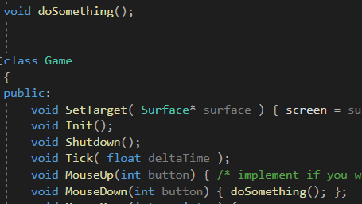

Aside from that, I’m really happy with how simple the movement itself turned out to be. I do imagine that setting the limitations and checking for terrain will be a little more challenging, but we’ll see.

Another thing I can do better is the logging of my progress; I made a lot of small changes over the course of these 10 days, which I always deemed too small to log, but which ended up piling up and becoming a pretty big change in the end. This has also led to me not noting down every single source I used over these last 10 days, which is probably the part I’m the least happy about. I tried looking through my browsing history to find the sites I used, but to no avail, aside from some very basic stackoverflow pages, out of which I already listed the most important ones. But, I intend to change all of these things in the future.

## Development 22/12/2020

By now units were able to move, but a few restrictions still needed to be implemented. Mainly; a maximum range for units to move based on the speed of the individual unit, and some sort of way for units not to pass through terrain/detect collisions. While the first part went rather well, the second part really ended up being quite the challenge. First things first, I wanted to see how to handle this situation. I initially thought to count the amount of steps required to get to a certain place; but this quickly got scrapped for a simpler solution. I added two 2 dimensional integer arrays. One called distanceMap which is the same size as the map, initially filled with 0s, and one called worldField, which would essentially contain the layout of the map, 0s meaning walkable ground, 1 meaning walls, etc. This array was kept to only those 2 right now, but would be expanded later with various different types of tiles. 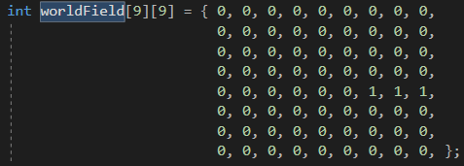

Above the map layout for testing purposes, which results in the following map: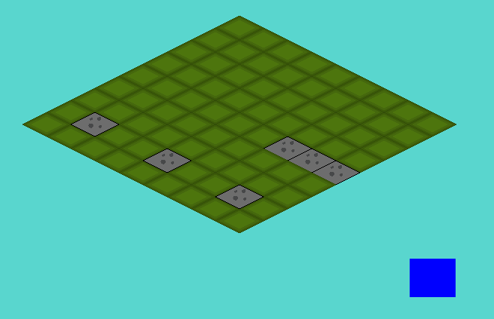

The player’s units should neither be able to pass nor land on these tiles.

With these arrays implemented, the following task was simple; set up a maximum range for the units, make sure they can’t land on terrain tiles nor other unit tiles, and make sure they can’t pass through these tiles. First things first was setting up a maximum movement distance for the units.

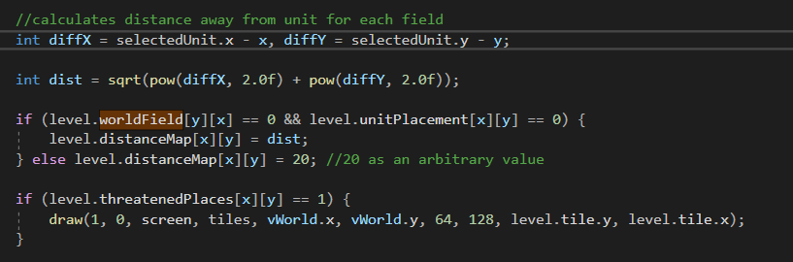

This code happens as the map is being generated, so will automatically loop over every cell. To break this down; the first thing that happens is the calculation of how far every cell on the field is from the selected unit. This is done fairly simply, just using Pythagoras. Doing this fills the array with numbers; 0 for the field the unit is on, 1 for every field right around the unit, 2 for every field beyond that, etc.

If the field at the given coordinates has a value of 1 on the worldField array, it gets a distance of 20. This value is completely arbitrary, and just had to be a value that the user couldn’t possibly access. (Note; the x and y values of worldField are swapped; this is simply for clarity’s sake in declaring the array)

When the distanceMap array is filled, I added a ‘speed’ attribute to my units, which would indicate how far a unit could move on the map. Once I added this, all that was left for me to do was add an if statement comparing the 2 values.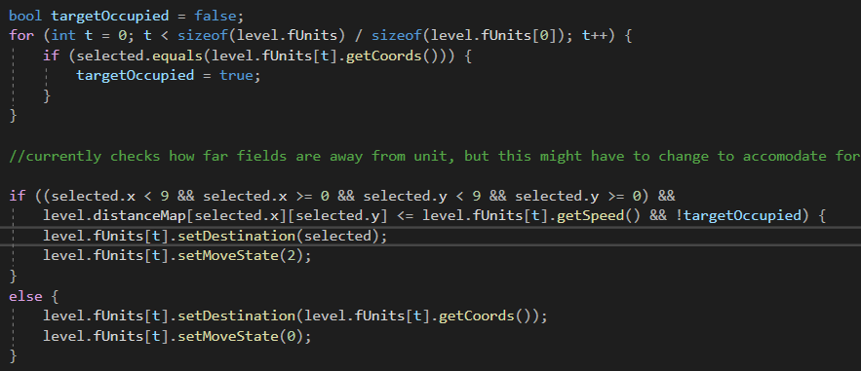

As can be seen in the code above, which gets executed in the doSomething function as described earlier, which happens when the player clicks, checks if the value on the distanceMap is less than or equal to the speed of the unit. Based on this, the unit can either move this distance, or, when clicked outside of its range, cancels its movement. This allows for very quick and simple movement of your units, and is also very easy to cancel if you’ve made a mistake.

There is another piece of code there, which determines whether the destination of the unit (called ‘selected’ for selected space) is occupied by a friendly unit or not. After this, I wanted to implement some sort of indicator for where the unit could move to. So, in the map generation, I added this piece of code: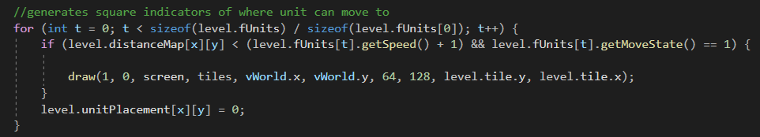

So, as it generates the field, for the selected unit, it generates all the fields the unit can move to. This looked something like this;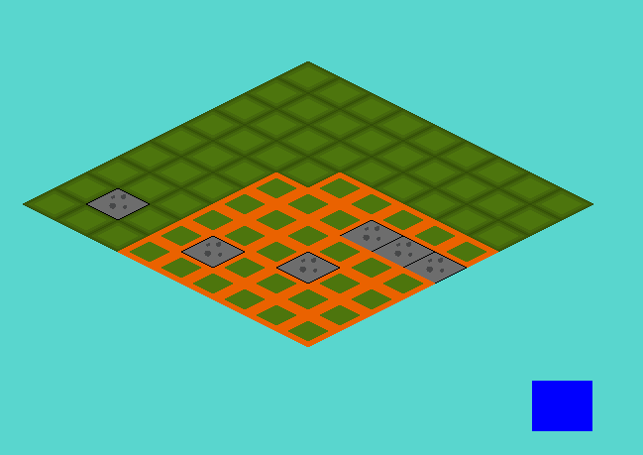

Which, for the time being, I was happy with. I decided to wrap up here, while I didn’t really accomplish much this day, this would suffice. There were still some problems; units could phase through other units or terrain as long as the destination wasn’t on another unit or on terrain, but at this point I decided to stop working for the day.

## Development- 24/12/2020

For this day, the plan was originally to implement collision. The idea was; if a wall or enemy unit obstructed the way, all fields that would be available behind them would become unavailable (see picture, but it would be simpler in game due to the grid).

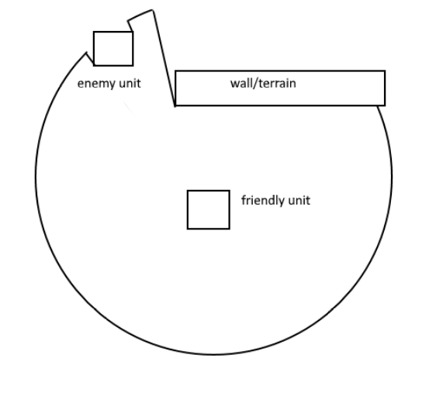

There were a few ways I initially thought to handle this: At first I thought of looking up ways dynamic lighting is done from a top down view12, and to try and replicate this. Secondly, when this proved too advanced and complicated, and just generally not really applicable, I looked into some other solutions. I thought of using something I’ve grown used to using through working with unity, namely raycasts. I figured trying to create something similar that would somehow mark all the tiles it passed, which would stop at tiles that aren’t indicated with 0 on worldField. This, however, also seemed to complicated for this. I broke my head about it the entire day, but never ended up actually doing any work, and ended up putting it off and deciding to work on it a different time.

1 <https://www.reddit.com/r/gamedev/comments/bpqqdg/2d_dynamic_point_light_c/> reddit link going into this topic

2 <https://www.youtube.com/watch?v=6B1IA_Tera4> video which ended up being pretty pointless, and I only really skimmed through it in the end.

## Development- 26/12/2020

Putting off movement for a moment, I decided to instead focus on creating enemy units and just the combat system in general. First thing I did was create an array of enemy units, which would be indicated by blue squares (as seen in the picture). These enemy units would remain completely stationary for now, but would come back later when working on the combat.

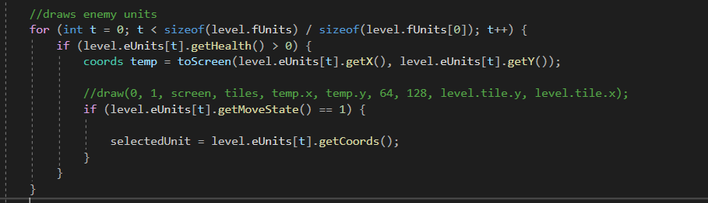

It just uses an array called eUnits (The screenshot was taken later, hence why it is also inside ‘level’, this will be elaborated on later). This array is basically a complete mirror of the fUnits array, with the same exact attributes, namely;

-X and Y coordinates  
-destination X and Y coordinates to function with the movement  
-health: the amount of damage a unit can take  
-speed: the maximum amount of spaces a unit can move  
-movestate: the state of the unit, either; hasn’t moved, is moving, has moved  
-isMoving: a check whether or not this unit is moving or not

Not that anything would be done with these enemy units for now, aside from them standing still, functioning as dummies for the friendly units to attack.

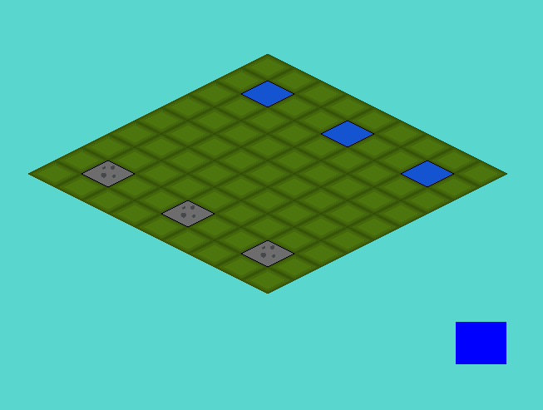

Additionally, I added a few parameters, which would check whether the destination of the friendly unit overlapped with any of the locations of the enemy units. So, to actually get started with the combat; I decided that, like in the game Into the Breach that this was in the end partly based on, for units to have 3 health (at least for now).

I had 3 ideas for different attack modes, namely the following;

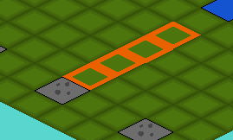

A long range attack with low damage, namely dealing only a single point of damage, which can hit multiple enemies at once.

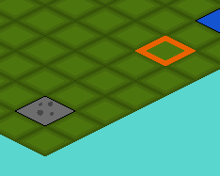

A long range mortar strike attack, dealing a medium 2 damage at long range.

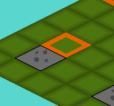

A short range melee attack, dealing a full 3 damage.

(These values were not set in stone at this point. Additionally, these screenshots were taken afterwards, for demonstration purposes).

I wanted these attacks to function as follows; as opposed to how the movement behaved, where units could move freely within a certain range, I wanted these attacks to have very strict patterns, and only work in either of the 4 main directions. How this exactly would be done was as follows; when the turnState variable was 1 (indicating it was the attacking phase), clicking on a unit would both reset their movement completely, just to be sure no odd bugs showed up while attacking, and then turn attackstate to 1, provided their attack state was 0. This was done in the same doSomething() function that was called for movement. Currently, I used the button I had implemented to switch between attack and move phase.

  
(Button for switching between attack and move states)

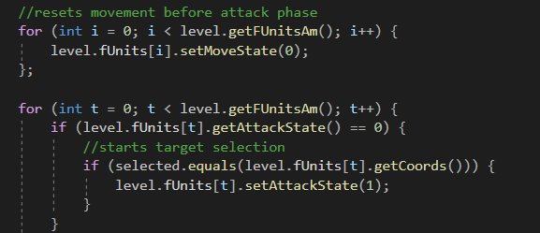

Seen above, the movement gets reset and then the attackState of the selected unit is checked; if it’s 0 as seen right here, it sets it to 1. Now, when a unit has an attackState of one, it has initiated its attack and is selecting a target. I knew that doing something similar as what I did with the movement would probably work, thus I went with that. I again made an array spanning the entire field, in this cased called threatenedPlaces, which would indicate all the threatened squares with a 1 and all the other squares with a 0.

Having said that, this was easier said than done. My initial plan was to add a method to the Unit class called something along the lines of ‘getThreatenedArray’, which would return a 2D array containing the entire threatenedPlaces array. I found 2 sources, one on Stackoverflow1, which I ended up basically copy pasting, and a video on youtube2, which never really ended up helping.

But returning a 2D array from a method deemed no easy feat. What essentially had to be done to accomplish this effect was to create an array of pointers, which all pointed to different arrays, essentially creating a 2D array. This ended up only half working, as I struggled a lot with actually getting the array from the method in ‘Unit’ in game.h to a variable I could use in game.cpp. It gave me a plethora of errors (of which I sadly have no screenshots as this was written after the fact and my code had already changed, regrettably), mainly one telling me I couldn’t copy an entire array into another one. After doing some debugging (aka logging the entire array through prints), I discovered the variables returned were pointers themselves. After doing a whole bunch failed problem solving, I attempted a different approach.

Instead of attempting to return an entire array through one method, I instead had the method determine whether a single field on the board was threatened, based on some given parameters.

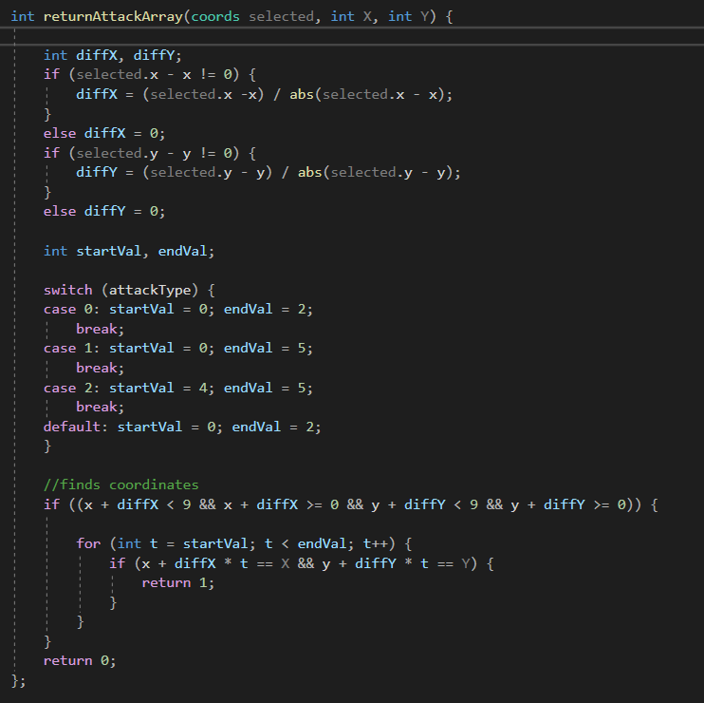

What happens here is fairly simple, and I’ll go over it step by step.

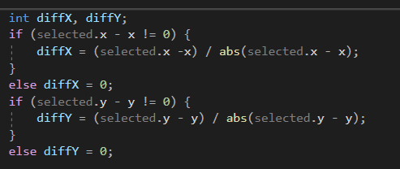

First things first, it got the difference between the selected field (the field the cursor was currently in) and the given parameters. If the difference wasn’t 0, I could get the normalized value out of it (either -1, 0 or 1). I had to use this roundabout and, honestly kind of ugly, piece of code to make sure no dividing by 0 errors happened at this stage.

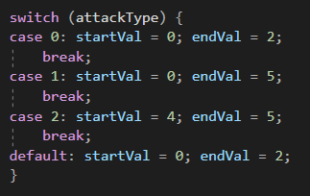

After this it checked what type of unit we were dealing with, according to a new attribute of the Unit class, which determined the attack type of the unit. Using this, I could set a certain starting and ending range of the attack, or I could potentially add even more complex attack structures in the future, but for now I would limit myself to these.

It’s fairly simple;

0-2 for melee, aka only the field in front of the unit,

0-5 for ranged, aka 4 fields in front of the unit,

4-5 for mortar, aka 1 field in front of the unit, 3 units away.

After this it was only a matter of checking whether these values actually existed, and then calculating whether the field given in the parameters is a threatened one or not through this piece of code, which returned 1 if it was and 0 if not.

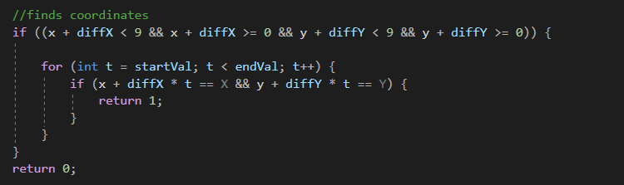

With this, all I needed to do to get the threatenedPlaces array was call this method;

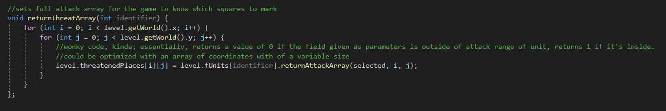  
(The comment is cut off but is non-important)

First things first, it takes the ‘identifier’ parameter, which essentially just means the index of the Unit that is attacking in the fUnits array. So for the first unit in the array, this would be 0, etc. Then it just goes through 2 loops, the vertical and horizontal length of the board, and fills up the threatenedPlaces array as it goes along, and ends up creating the entire array like this.

Following this, I had to call this function. So, in the piece of the game::tick loop where it loops over the units to draw them, I conveniently added a piece of code that would call this function when a unit is attacking.

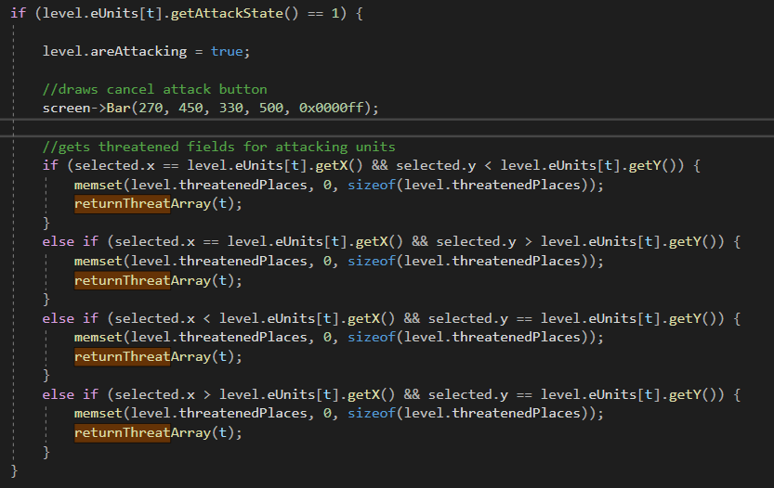

This is again not too dissimilar from how I handled it with the movement, although this time there are a few complications. First thing at the top is a variable called areAttacking. This is essentially just used in the doSomething function to check if units are attacking. Then it draws a bar. This is because; later on in the code I made it so the attack can not be canceled like one would cancel movement, e.g.: by clicking off the board or outside the range, so instead I had to find another way to let the player stop their attack. This was done by adding another button to the left of the board, which, when clicked, cancels any and all attacks being made by the player. The drawing of the attack indicators happens just as the movement indicators are drawn; when generating the board; if the threatenedPlaces array is 1 at the given x and y coordinates, it draws an indicator square.



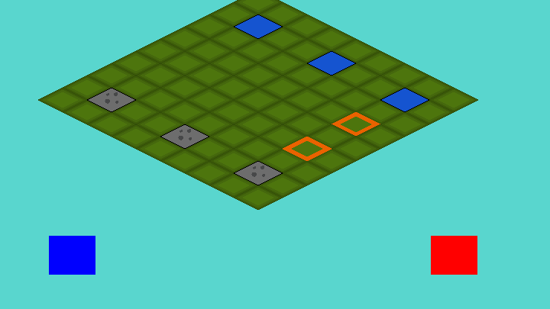  
(Cancel button can be seen on the right. Note; there are 2 orange squares, one is the mortar target, the other one is just the cursor.)

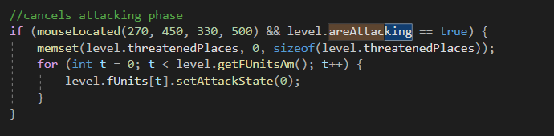

And this is the code for said button, located in the doSomething() Function. It checks if the cursor is on the button and if the areAttacking function is true, at which point it enables the button’s functionality. When clicked, it sets the threatenedPlaces array to all 0s, using memset34.

Now this function is out of the way, to get back to the code shown earlier, namely this code;

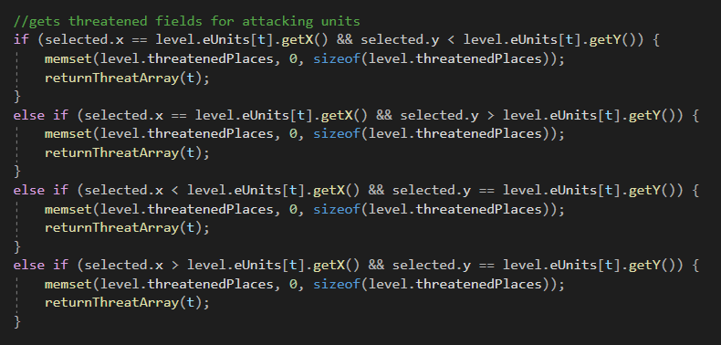

What exactly happens here is as follows; whenever the cursor hovers any distance over any of the 4 directions, the attack angle is set to that angle and stays there until the player hovers over another direction.

So there it was; all that needed to happen now was check if the attack actually hit. This was surprisingly easy; whenever a unit is attacking, when the player clicks anywhere (aside from the cancel button), the attack goes off, and when it does, check whether any enemy unit is located on a field where threatenedPlaces equals 1; et voila! They took damage when the player clicked again.

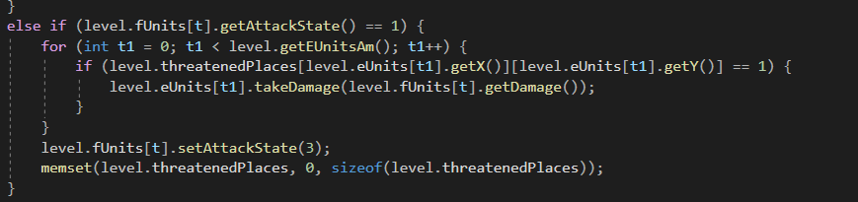

### Sources

1 Source to the stackoverflow page about returning 2D arrays: <https://stackoverflow.com/questions/8617683/return-a-2d-array-from-a-function>

2 Youtube video about passing 2D arrays: <https://www.youtube.com/watch?v=QEKmS221MtM>

3 Stackoverflow page about setting an entire array to 0: <https://stackoverflow.com/questions/5636070/zero-an-array-in-c-code>

4 Reference page about memset: <http://www.cplusplus.com/reference/cstring/memset/>

### Reflection

Everything went really smooth this day, and a lot of work got finished. At the end of this worksession, I decided that I wanted to put every global variable I had (of which I had a lot, mind you, e.g.: threatenedPlaces, placesToMove, etc) into a single class, but I decided to do this another day.

## Development- 28/12/2020

With the combat finished for now, I wanted to do some cleaning up in my code. I had a lot of global variables at this point, which I all wanted to add to a gameState class.

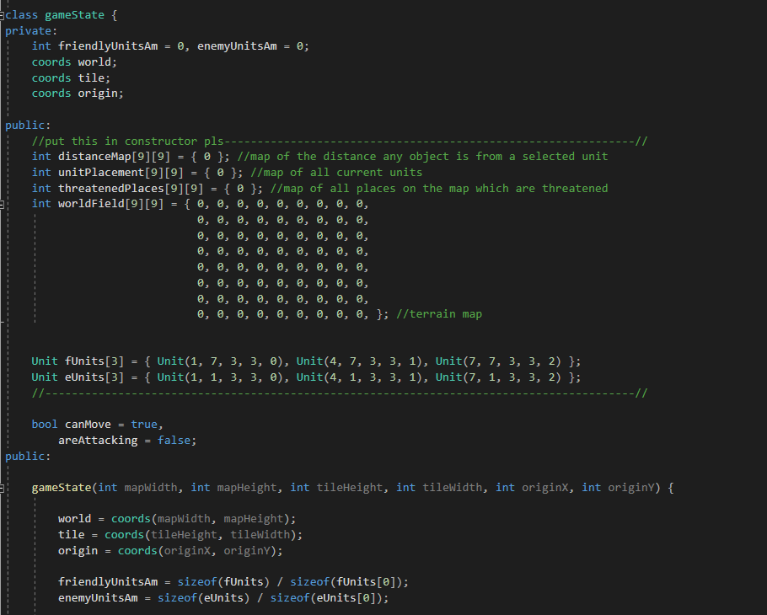

This is the gameclass I ended up with after adding any variable that I deemed to belong in this class to the class. This was an extremely simple, yet tedious and boring process; I essentially had to change every mention to variables in the code currently, and I still was not happy with the state of this class at this point. The main problem is the fact that all the arrays that are used (distanceMap, unitPlacement, etc) are both set to public and their values are hardcoded. The reason for its tediousness however was that, in the game.cpp file, I had to replace every occurrence of these variables to one that works with the new setup.

Now, this wasn’t good yet; I still wanted to clean this up by making both the unit arrays and the map arrays private. Additionally I wanted to make both the unit and the map arrays variable in size, in order to quickly and more easily change the layout in order to create more complex levels really easily and quickly. This would be tricky, as C/C++ doesn’t really allow dynamically sized multi-dimensional arrays, and passing them through a get-method would be one hell of a task to take on. I knew it was possible, or at least I knew something similar to what I wanted to achieve was possible by using pointers1, however, at this point my exams were slowly coming up and I started to get less and less time to actually work on the game, thus I decided to leave it at this and continue working after the exams.

I knew I’d have to do a lot of tedious work in doing this, and I decided I would rather spend my time studying than I would spending it fiddling with variables, for the time being. I would, however, return to this after the exams as soon as possible.

1Source for how multidimensional arrays would work in C/C++ <https://stackoverflow.com/questions/1946830/multidimensional-variable-size-array-in-c>  
I ended up putting this off for now, deciding to get back to this later.

## Development- 14/01/2021

While I couldn’t work like I normally would during this period due to me having exams which took up a lot of my time. Nevertheless, I squeezed in a bit of work here and there and managed to get some work done yet.

I changed the moveUnits function to accommodate for both friendly and enemy units, allow both of them to use the same function rather than the same function copy pasted twice. I changed this to now use a pointer to the values, rather than having it be hardcoded. This way I could use this same function twice for both enemy and friendly units, without cramping up my code with nasty copy-pastes. This was however all I did this day, as I was still in the middle of my exams and didn’t have much time to spend on these developments.

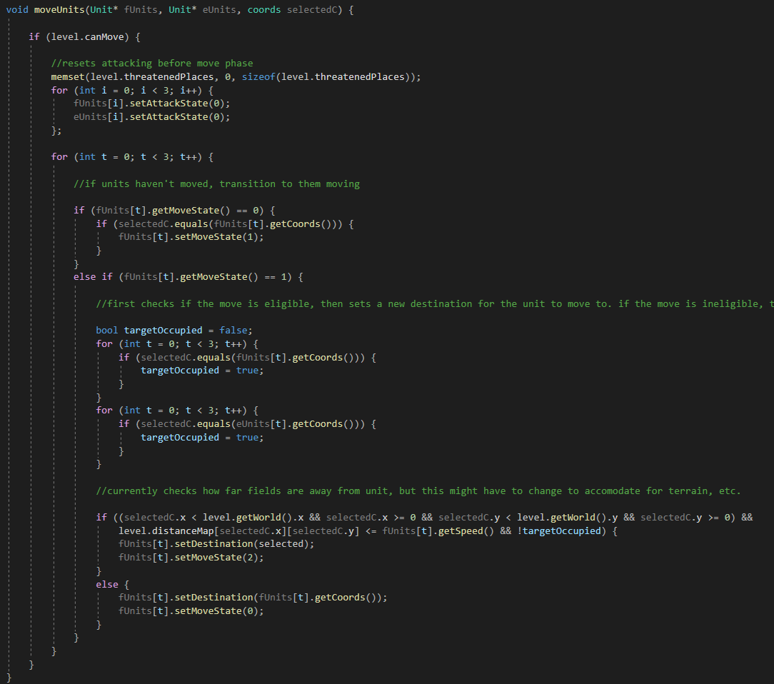

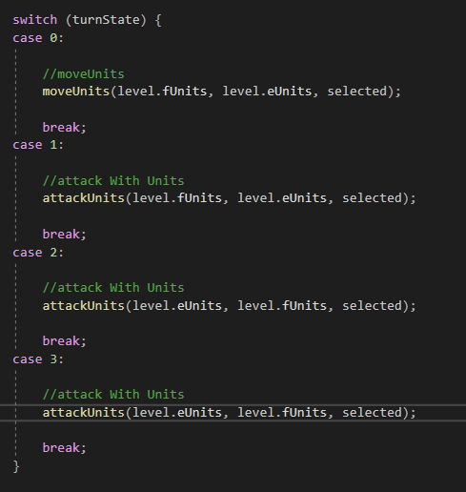The way this works is as follows; when calling the function, it asks for 3 parameters, namely a pointer to the friendly units, a pointer to the enemy units, and the selected field. The selected field was just a matter of passing a coordinate, simple enough. For the others, I could simply pass the array. This made everything suddenly a lot cleaner, although I wouldn’t realize just how exactly what I just did worked until a few weeks down the line. This was just some random idea that popped into my head after hearing about pointers here1, and I ended up using them without really understanding them fully yet.

To the right is the code where the functions are actually called; depending on the current Turnstate, which is changed by the blue button, different functions would be called. This is where the blocks of code that managed the movement and the attacking used to be, now neatly stored in functions which are called here.

Below is the attackUnits function, which shortly gained the same treatment. After these few minor changes, I had to go back to studying for the time being as more exams were coming up, so I wouldn’t be able to properly work on the project for a fairly long time after this.

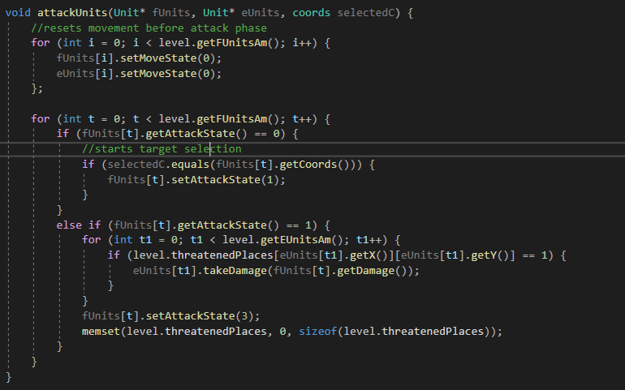

1<https://www.youtube.com/watch?v=iChalAKXffs>

A video, uploaded by the same person as the one who I followed the isometric grid video for. At this point however, I didn’t get the video exactly, and more so skipped through it rather than properly watching it, leaving me still none the wiser

## Development- 01/02/2021

After my exams were over, and I took a week-long, well deserved break, I could finally get back to working on my game full time. At this point we had reached February, meaning I only had about 3 and a half months left to finish this. Considering everything that still had to be finished up until this point (the movement, AI, UI, menus, etc.), I had no shortage of work to do and jumped right into it.

The first change was something I realized after having made both the attackUnits and the moveUnits functions dynamic, and that is that I could manage both friendly and enemy units at the same time anywhere in the code. And so just as I had changed attackUnits and moveUnits, I changed the drawUnits function to now account for both sides using pointers.

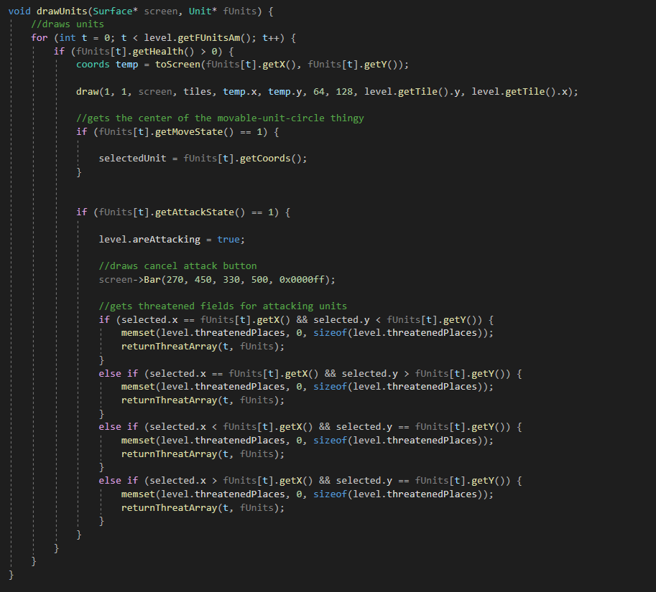

This change did however mean that I would have to rewrite the lambda statement that was currently converting the ingame coordinates to onscreen coordinates into a proper function. This wasn’t a big deal of course, and only took a couple of seconds.

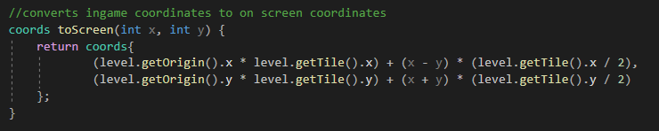

This being finished, I added a parameter to the function, so it would be dynamic even for higher or lower counts of units, as seen below.

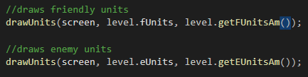





With that done, I decided to avert my gaze upon the movement to have another crack at that. With the combat in place, finishing the movement was now an essential component to finishing the game, with the AI being unable to actually work if the movement isn’t working.

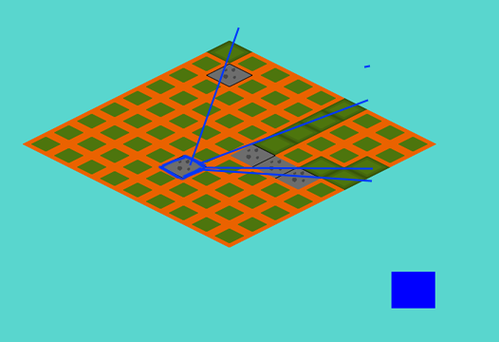So, according to the idea for movement that I had earlier, where walls would block your path, I got to doing my maths. The initial idea was as follows; for every wall tile, unit tile or any other tile that the player would collide with, I did a calculation; I calculated the direction vector1 between the current moving unit and the collision tile. Using this, I extended this vector to behind the wall unit to form a line. This worked; to a certain extent. As you can see in the picture below, the unit marked in blue can’t move pas the wall tiles.

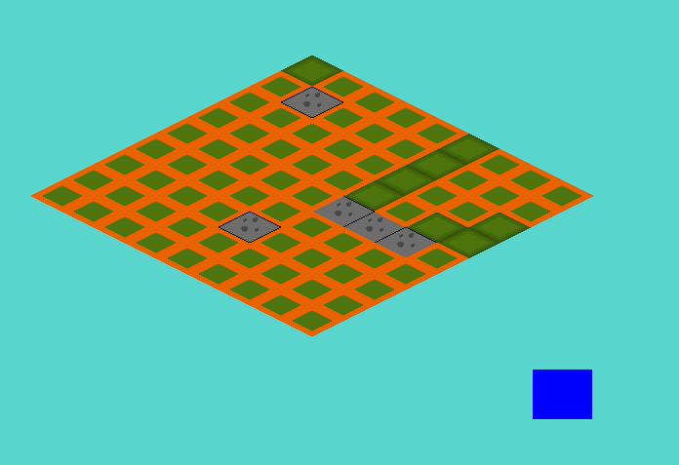

Now, there’s obviously a problem here. A few, in fact. Let’s go over them; first of all, due to the fact that the distance calculation was still done in integers, alongside the fact that the round() function was used in a couple of places, made it so the lines projected behind the wall tiles are exclusively in either 90deg or 45deg angles, leaving those massive holes. But those holes had another reason for existing; considering the lines were only one tile thick, having a wall of 3 tiles for example, couldn’t block out an entire zone behind it, due to simply not covering enough area.

Below, you find the first attempt at the code for this;

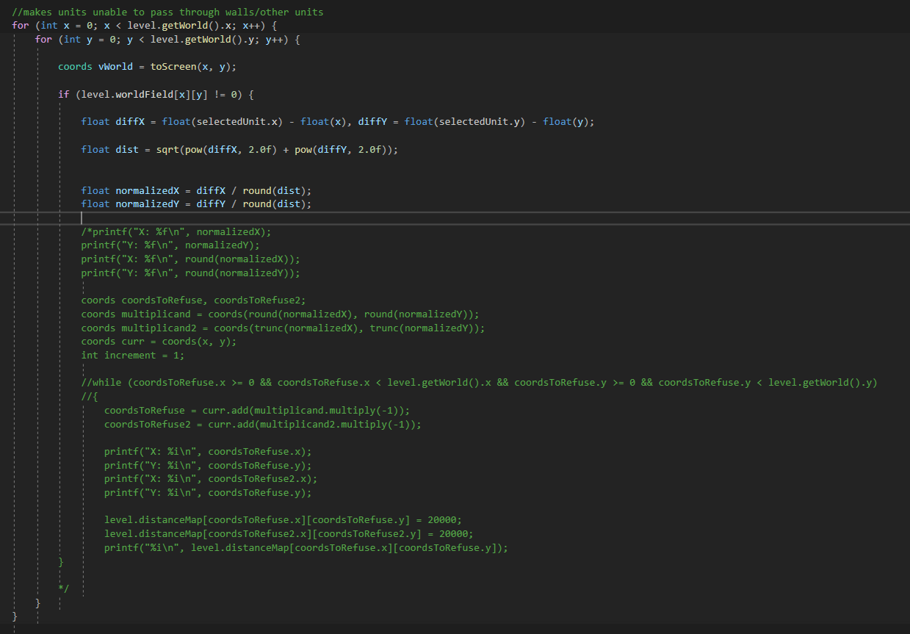

A lot is commented out due to this not properly working at all, but the idea was there already; the coordsToRefuse variables would block out the fields behind the unit through a while loop, getting incremented over both x and y axes, until they hit the edge of the map. And after just a few tweaks, the effect that I showed in the pictures earlier was achieved. But, there were still those issues I talked about earlier. And for that, I came up with another idea; where, from every single tile that was disabled from the collision detection (the ones not marked in orange on the prior images), a second line would come which would be limited to the 90deg angles, which would then fill out the space behind the walls completely. The biggest problem here was calculating the directions these lines should go in; whether they should go along the x or y axis.

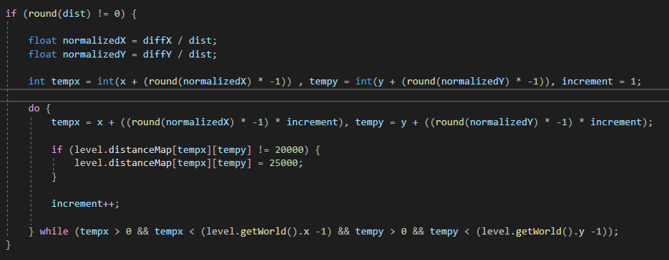

Source for vector normalization

1<https://www.khanacademy.org/computing/computer-programming/programming-natural-simulations/programming-vectors/a/vector-magnitude-normalization>

Source for float conversion from integer division

2<https://stackoverflow.com/questions/16221776/why-dividing-two-integers-doesnt-get-a-float>

## Development- 06/02/2021

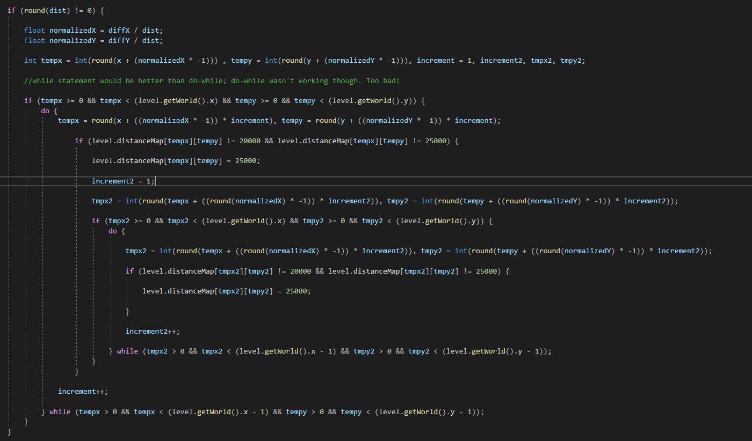

For today I wanted to finish the code for blocking out spaces behind walls. How I initially planned on doing this, as seen above, was as follows; for each obstacle tile, the code would draw these lines where the unit can’t move to, which was calculated by getting the directional vector between the unit and the obstacle tile and continuing that line. Then, when all the lines were drawn, for every single erased field, it would continue straight onwards to the edge of the map, away from the unit, essentially filling the zone between the lines drawn. This didn’t quite work out however; while the lines were drawn normally, filling the space behind turned out to be quite a task.

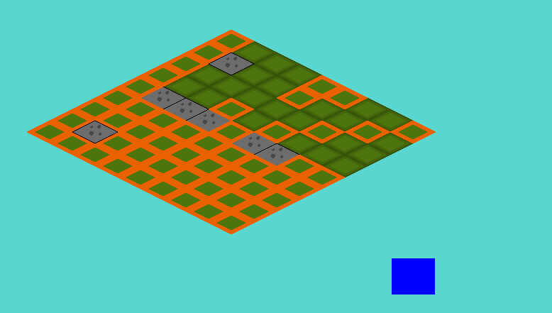

Above is shown how the results were choppy. However, after sitting down and properly thinking about how I wanted to handle this, another idea sprang to mind; I got the idea to change how movement worked entirely. Now, instead of clicking on the unit you want to move and then clicking on the destination, after which the unit would automatically move to said destination, the movement itself was done by clicking on the unit and then selecting one of 4 squares around them, if possible. This would erase the problem of checking behind walls, as I can simply disable the squares around the unit which the unit can’t move to. And so I got to work! I initially just changed some numbers around to make the code I already had emulate the new idea (essentially setting the maximum range for possible move to 1 tile) to confirm whether or not this worked, and when testing it I found it worked wonderfully!

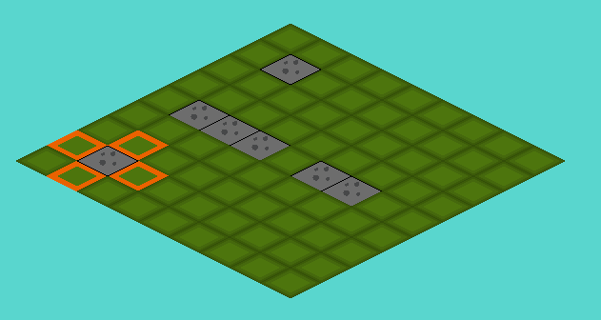

Above you can see the unit preparing for movement around it

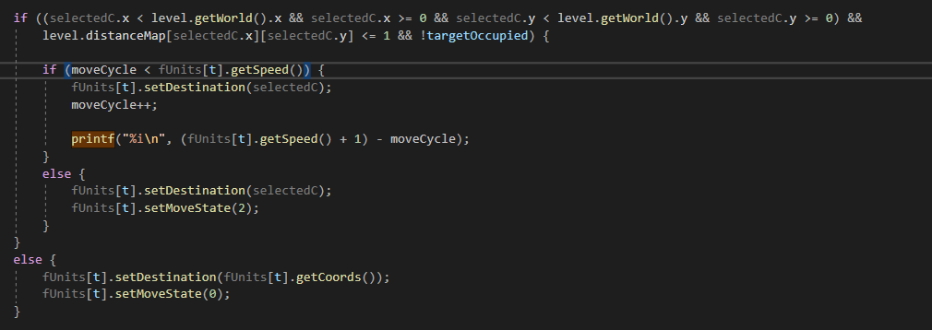

Above is a part of the code which essentially checks whether the unit can still make moves (see the if statement comparing moveCycle, aka the amount of moves already made this turn, to the units movement speed).

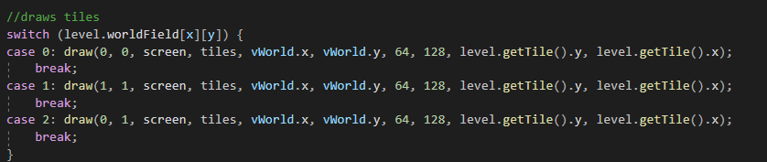

As a last thing this day, I added water tiles, which would only be accessible to non-grounded units, and objective tiles, which would serve as an objective to destroy for the units. The plan here being that, once either all units of a team are destroyed, or the objective is destroyed, the other team wins the match.

### Sources

Reference for dynamically sized arrays in C++, which I initially wanted to use for the arrays of tiles which would be deselected for movement  
<https://www.geeksforgeeks.org/variable-length-arrays-in-c-and-c/>

<http://www.cplusplus.com/forum/beginner/1601/>

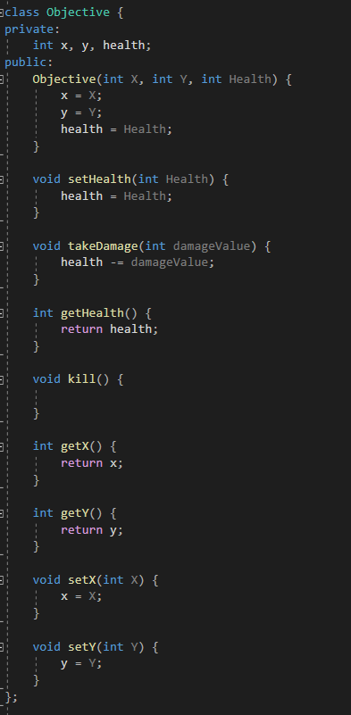

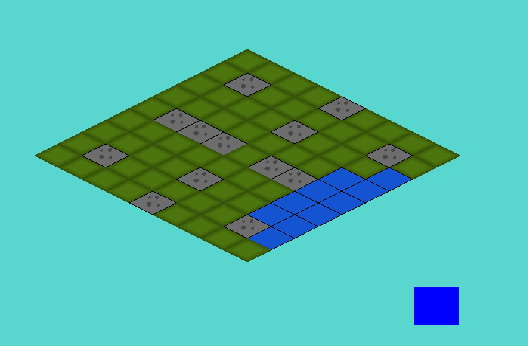

Fixed unit death by moving units to -1, -1 when they reach 0 or less hp

Added enumerators for unit types and unit direction

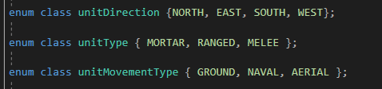

Divided units into 3 types of mobility; naval, ground and aerial

Naval: only water

Ground: only ground, blocked by mountains

Aerial: van move anywhere

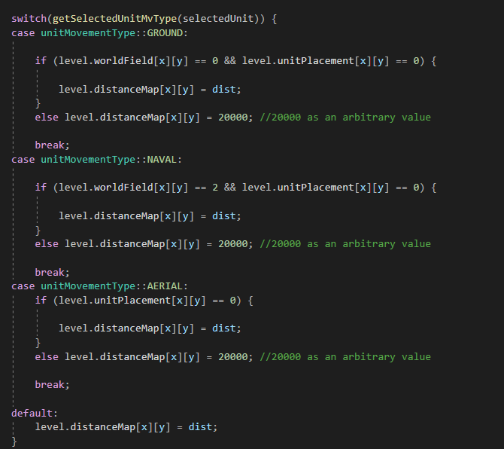

Modified unit interaction with terrain based on movement style

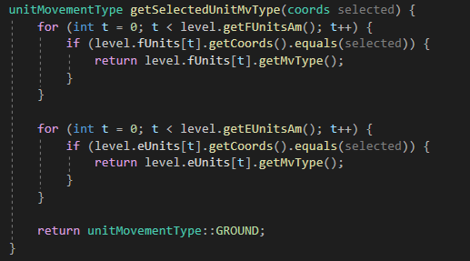

Gets movement style from selected unit

## Development- 08/02/2021

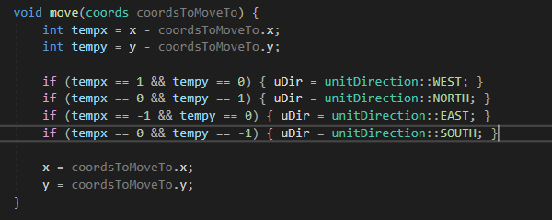

I didn’t do too much work today, but essentially; for spriting reasons I wanted to store the unit’s direction, to display them always looking to the direction the player is moving them in. I did this fairly simply, by subtracting the current location with the new location the unit moves to, and then based on the result checking what direction they’re facing and assigning the sprite using that. For this, I did make an enumerator to store the 4 cardinal directions in, and I also gave every unit a unitDirection attribute to determine its direction.

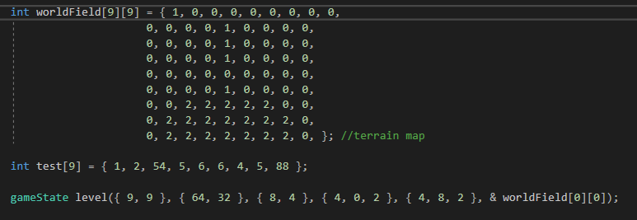

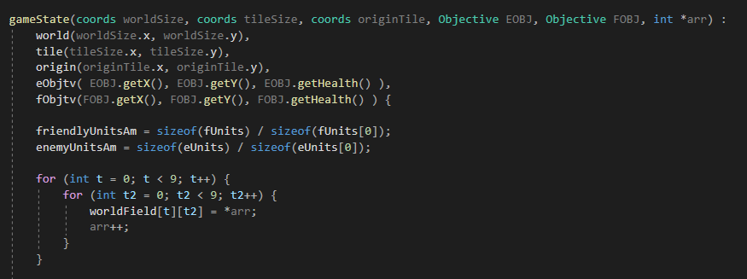

In addition to that, I changed the gamestate constructor around a little. Now, rather than the worldField array being separate as it used to be, it’s actually generated prior to the instantiation of the unit and is passed into its constructor using a pointer. It actually took me a surprisingly long time to wrap my head around using pointers for this, but I eventually managed to get the hang of it.

### Sources

Sources on how to pass arrays as pointers in a constructor

<https://stackoverflow.com/questions/9426932/how-do-i-pass-an-array-to-a-constructor>

<https://stackoverflow.com/questions/9802341/constructor-and-initialization-of-custom-classes-objects>

<https://en.cppreference.com/w/cpp/language/constructor>

reference used for change in constructor of gamestate object

<https://www.youtube.com/watch?v=iChalAKXffs>

## Development- 09/02/2021

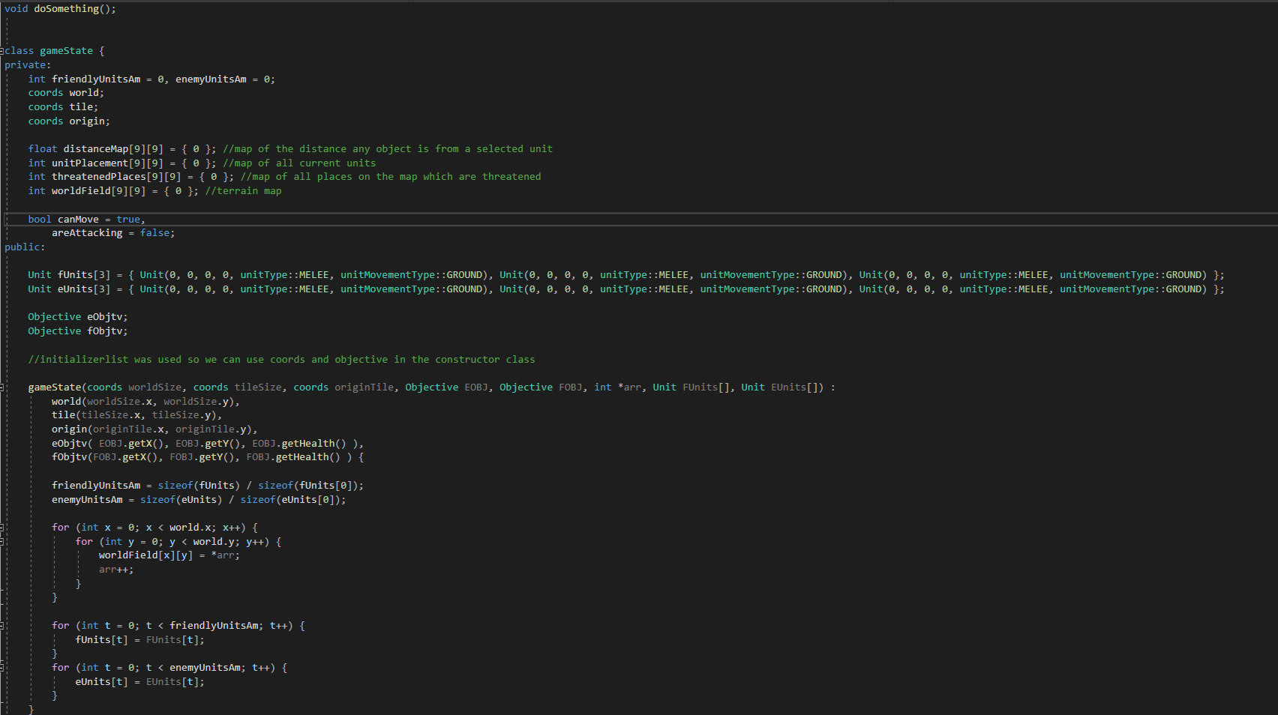

Above is the updated gameState object, which now contains all 4 of the important arrays which are used to manage the game (distanceMap, unitPlacement, threatenedPlaces, and worldField). Additionally, in the same way I passed the worldfield array to the gameState constructor using a pointer I now add the unit arrays the same way. This is as preparation for when I eventually add multiple levels to the game. Furthermore, I reasoned that, seeing as the tileSize won’t change from level to level, that there was no point in storing this set of values in the gameState object. Rather, I saved them as a static constant variable.

Alongside this, I changed a lot of variables from public to private fields, adding accessor and mutator methods. I did this with the idea that it’d be more in compliance with standard OOP conventions.

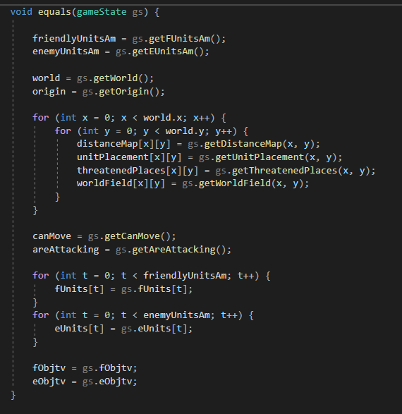

I also added an ‘equals’ method, which overwrites an instance of gamestate with another instance of gamestate. Using this, I could store and overwrite levels easily by just calling this method.

## Development- 12/02/2021

I initially changed around the gameState constructor to not take objects, rather take loose variables and form variables from them. The reason for this was fairly simple; in the old version of the constructor, I take the attributes of the objects I passed as parameters and assign them to new objects, which are attributes of the main gameState objects. Essentially what I was doing was as follows; making an object, breaking it down to its individual attributes, and then building it back up in the constructor. Of course, it makes no sense to do this; why build up the object only to then break it up again, only to build it up yet again? However, when I actually implemented this, I thought it looked very unclean and it ended up being very confusing to manage, so I changed it back and kept it like that.

I also made an array of gameStates, to accommodate for the multiple levels which would eventually be implemented.



I turned the array worldfield into a 3 dimensional one, which would store the layouts for the levels and pass them into the gameState objects. Now, I have to mention one thing; this is very inefficient. Right now, I’m creating a massive array, then passing a pointer to it to the gameState object, and copying it into it through the use of for loops. That’s a lot of ram dedicated to variables that won’t ever be used, so I have to look for a way to solve this issue. But for now, I think this looks about fine.

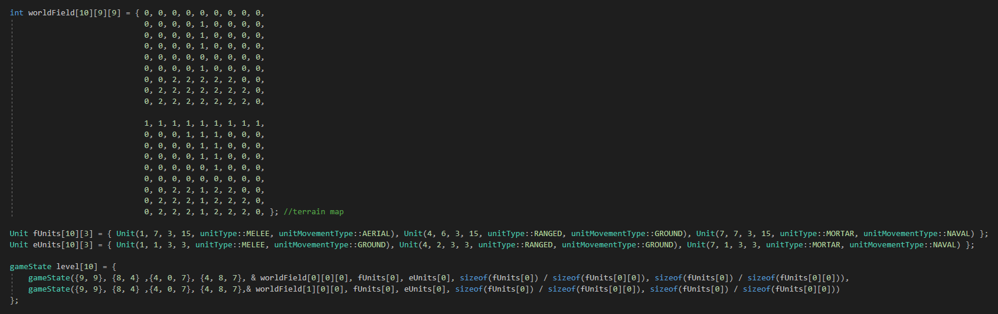

With this, given it would take some work, I could change the level the player is currently on by just changing a single value, ‘lvID’, a global variable which I would use as the index for my level array.



Also; I finally figured out how to give this function a body in game.cpp! I’ll admit, this took me way too long, but hey; I figured out what function prototypes are now!

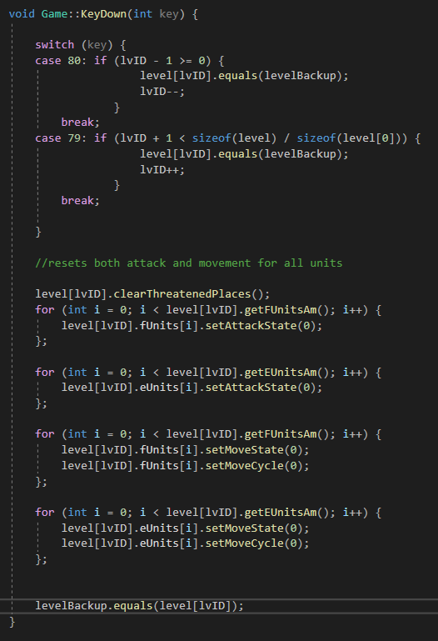

Above is some code I wrote which checks for inputs; this is a temporary solution to switching between levels I added just to make development easier, but it’s the first instance of me reading keyboard inputs so I thought to include it here.

The game is basically functionally functioning now; the only things left on the to do list are the following:

-add a backtracking element to unit movement, so you can undo your own movement, to add some user-friendliness  
-add the enemy AI  
-add all the spritework  
-add a UI and a menu

Now, it might seem like this is a lot of work still left to do -and it is, don’t get me wrong- but I think I can manage all this. The AI itself seems like a challenge, but I’m ready to start working on it.

## Development- 13/02/2021

Additionally, I added an array for every unit which would store the past moves it has made this turn. This way, when the unit moves again, it can check this array for the last entry, and if they coincide, the unit gets one movement tile back. This is done to prevent users from accidentally wasting a tile of movement due to a mistake. The final move still locks the unit into place for now, which I will fix with a UI element.

Below is the backtracking code; as you can see, it first compares the current position to the position the unit will move to, to get the direction, which is mainly done for spriting. It then stores ‘x’ and ‘y’, which are the current positions of the unit before its movement goes through, in the array. It then checks whether the position the unit moves to is equal to the last element of the array, and if so; reduces the moveCycle by 1. The last bit of code is temporary, but essentially it states that if the unit has made its last move, it clears the past places and finished the move.

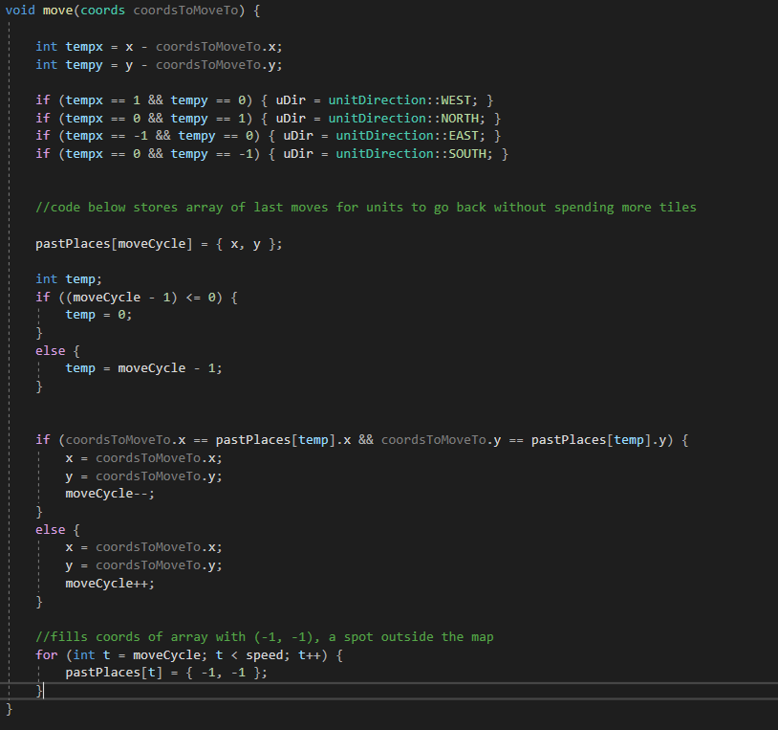

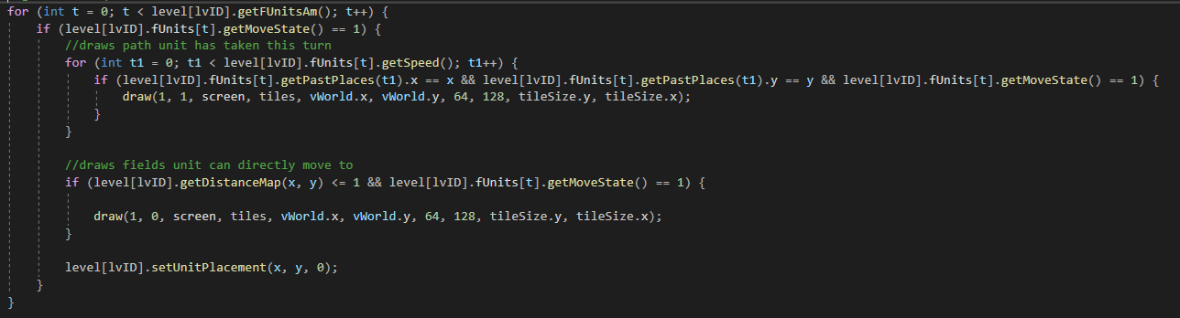

Above is the code used to render the past places the unit has gone to, which currently uses one of the 4 only tiles I’ve drawn up.

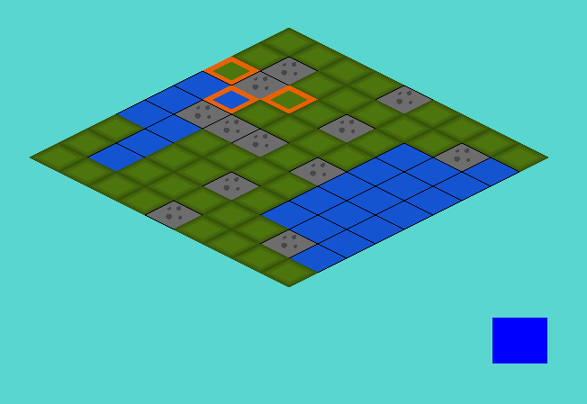

Blue squares behind the selected unit (as indicated by the orange tiles surrounding it) are the path the unit has taken. These tiles are only visible when moving the tile itself.

## Development- 14/02/2021

Finally, I got to the point where I could start working on the AI. This’d be a big challenge, so I wrote up a flowchart of how the AI would work, just to visualize the process I’d have to program.

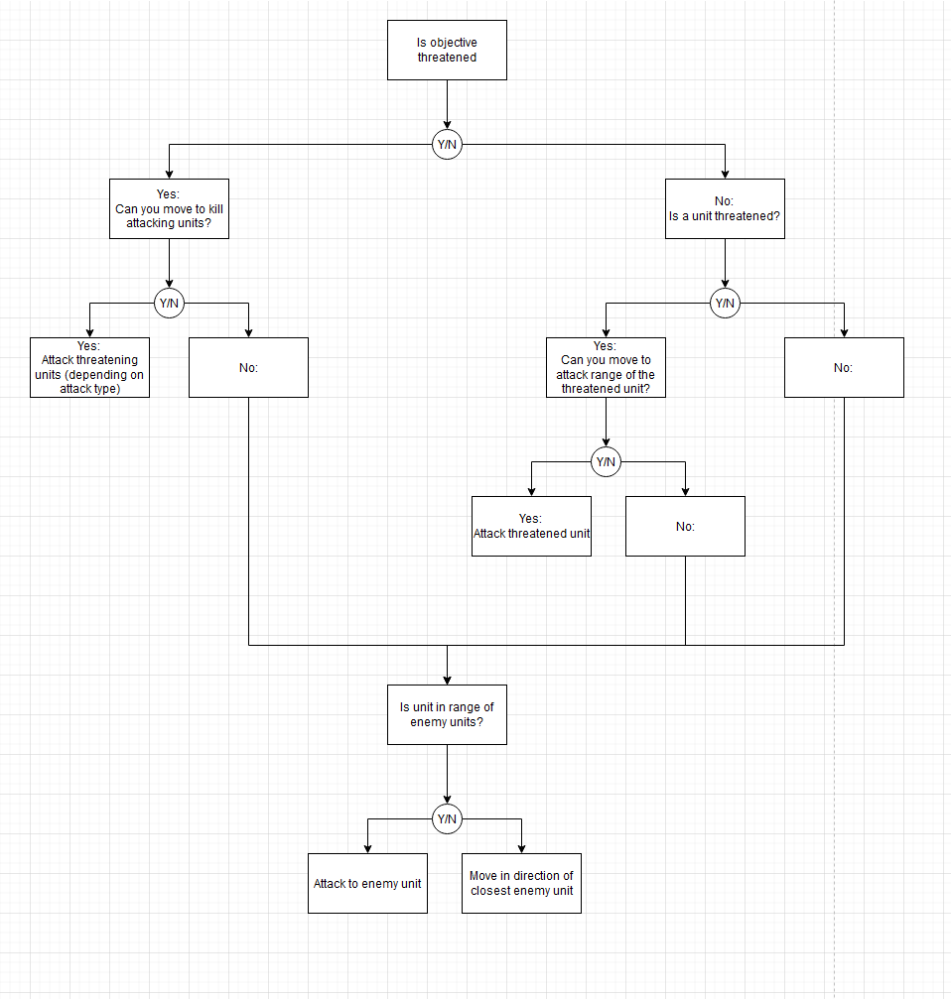

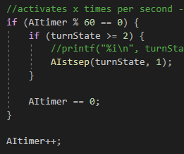

How I planned this out was as follows; every second, the game checks whether the turnState is greater or equal to 2, which would mean it’s an enemy’s turn. If this is the case, it activates the AI function, which is called AI step. Here the program would handle the AI’s movement and activity, as shown below.

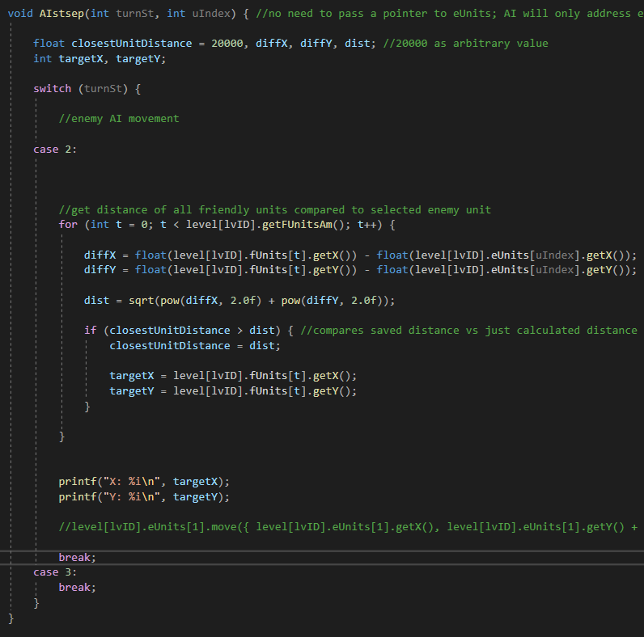

In the code above it just logs the coordinates of the closest unit the AI should target, but this will be improved later on.

Additionally, drew some characters the player will face over the game, as I wasn’t really in the mood for coding today. I’m kind of happy with them, and even came up with some little stories for them I’ll detail under their pictures.

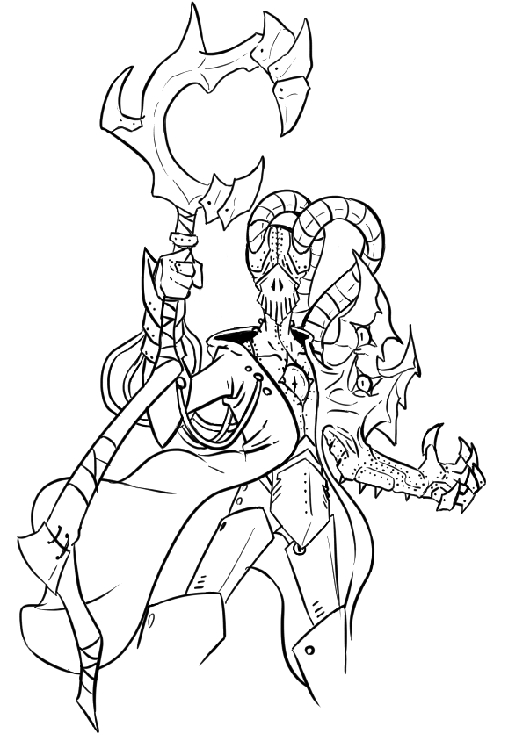

I haven’t come up with any names, but this is the leader of an alien race which has rejected their mortal flesh, for a mechanical alternative. Think the Adeptus Mechanicus from Warhammer 40k, but more our for blood and with a tendency to force people to adapt to their mechanical ways.



Yes yes, the helltaker influence might be kind of obvious in this one, but hey; having a pretty lady talk to you can’t ever be a bad thing, right? (I know, pretty uninteresting and generic design, but I thought it was a pretty fun design)

## Development- 15/02/2021

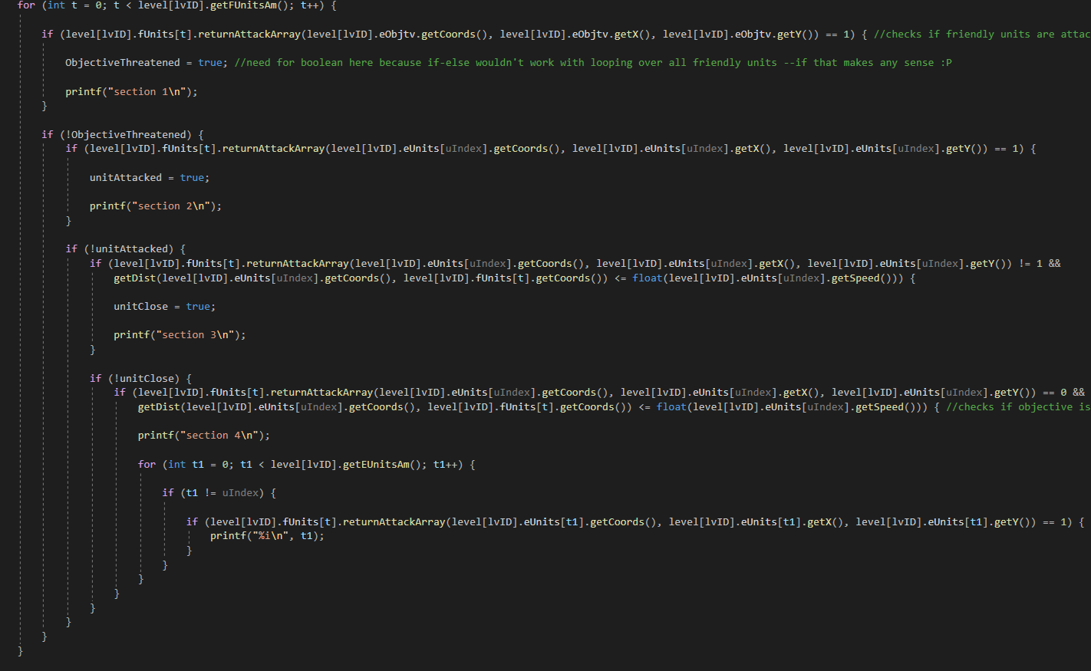

Above is the first iteration of the targeting function; it’s still pretty buggy and the code is incredibly hard to read, but it essentially goes as follows:

1. Check if the objective is threatened, if so; defend it.
2. Check if the unit is under attack, if so; it defends itself.
3. Check if a unit is close enough for the unit to attack it, if so; attack it.
4. Check if an allied unit is threatened somewhere, if so; defend it.
5. If all other steps fail, find the closest unit.

However, in the code above, the units aren’t actually targeted yet, rather the program prints to console that a unit has been found.

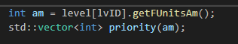

Here’s the array for all the units which should get checked for targeting, which get added to this array depending on whether they’re alive or not.

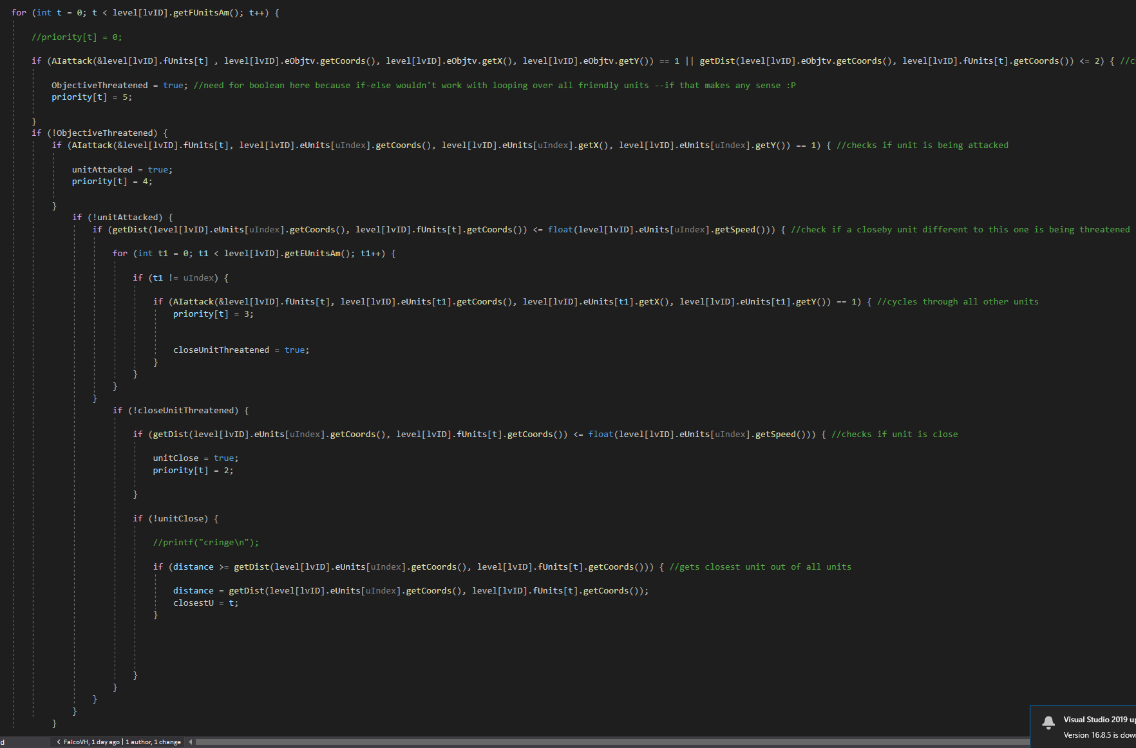

After some tinkering, I updated the targeting code; now, instead of the printing to console, it gives the units a priority level, ranging from 5 to 1, based on certain criteria, which are largely similar to the previous iteration of the code.

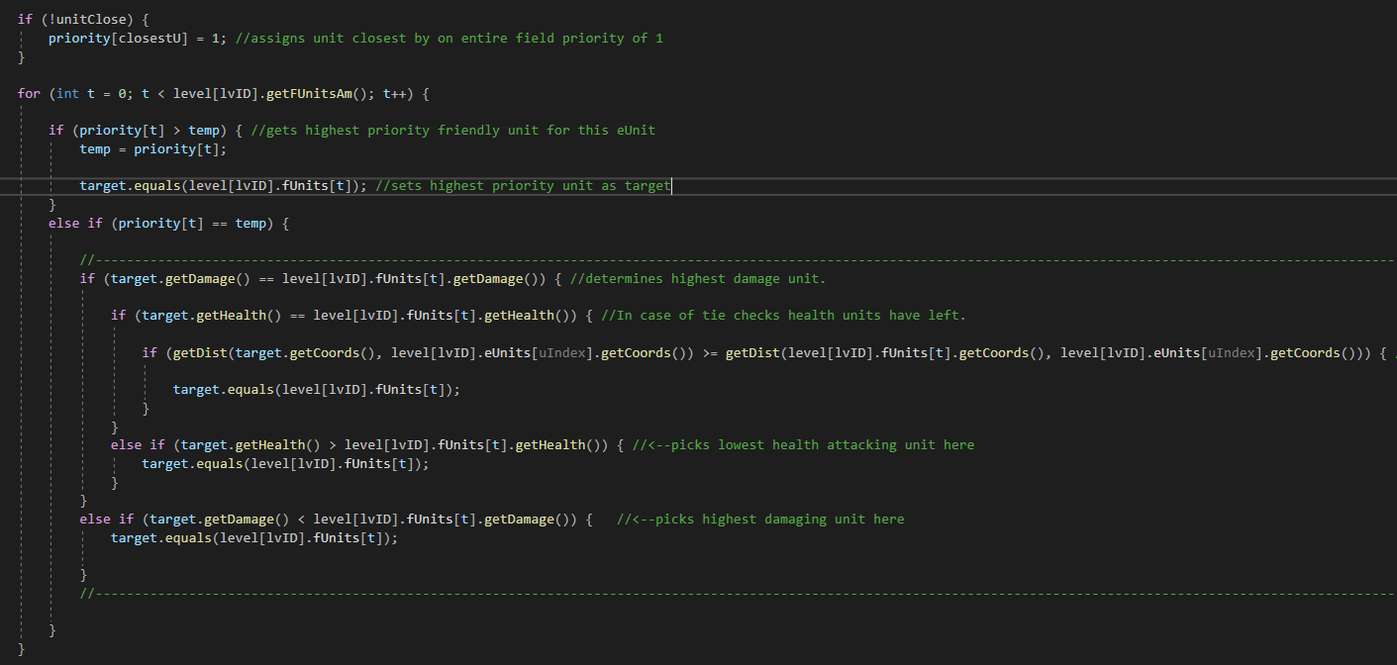

Now, in case of a tie, the code above determines which of the tying units is targeted by the AI.

1. The unit that could deal the most damage
2. The unit that has the least health left
3. The unit that is the closest by

### Sources

<https://www.geeksforgeeks.org/variable-length-arrays-in-c-and-c/>

<https://stackoverflow.com/questions/15013077/arrayn-vs-array10-initializing-array-with-variable-vs-real-number>

<https://stackoverflow.com/questions/13431567/how-to-make-an-array-with-a-dynamic-size-general-usage-of-dynamic-arrays-maybe>

## Development- 16/02/2021



I didn’t do much today, the only thing I did was remove the distanceMap and the threatenedPlaces from the gameState object. The reason for this was fairly simple; these 2 arrays constantly get completely changed, and aren’t dependent on which level the player is on. So, I reasoned they could just be removed to save some memory space.

## Development- 18/02/2021

I continued work on the targeting today; while the code now already targets a single unit to attack, it still needed some modification. You see, the actual location the unit should move to shouldn’t be the same location as the unit, rather a position on the map the unit can attack, or a location the unit could move to in order to get in range of the targeted unit. Below is the code I used for this:

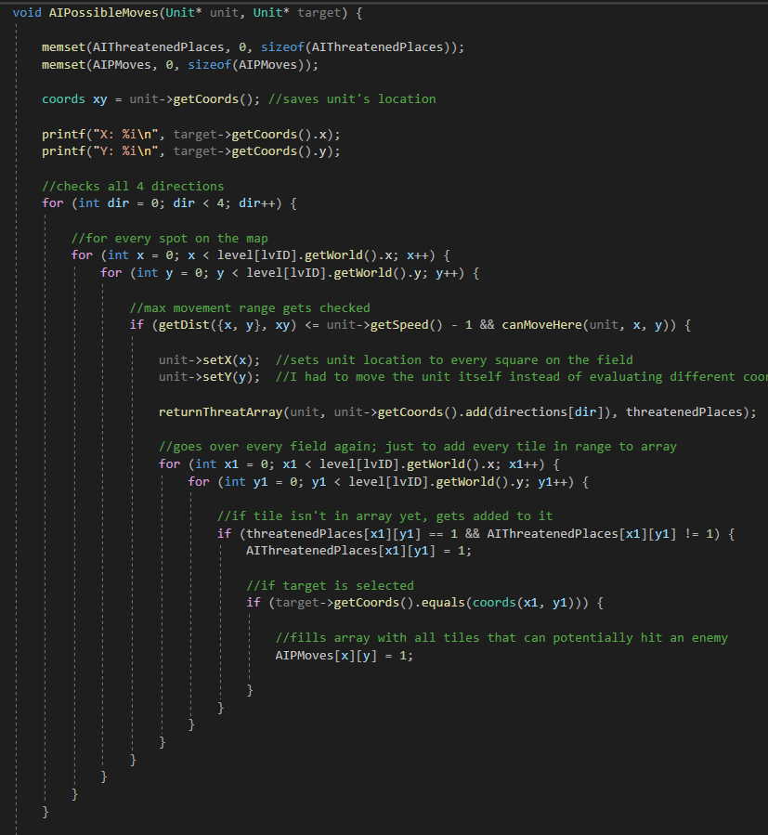

One interesting bug I encountered was that I had to move the unit across the field, instead of just entering different coordinates to test it out. So, I stored the unit’s original coordinates, then moved them across the entire board, to then move them back. A pretty roundabout solution to the problem, but it doesn’t seem to be causing any issues so I left it at that.

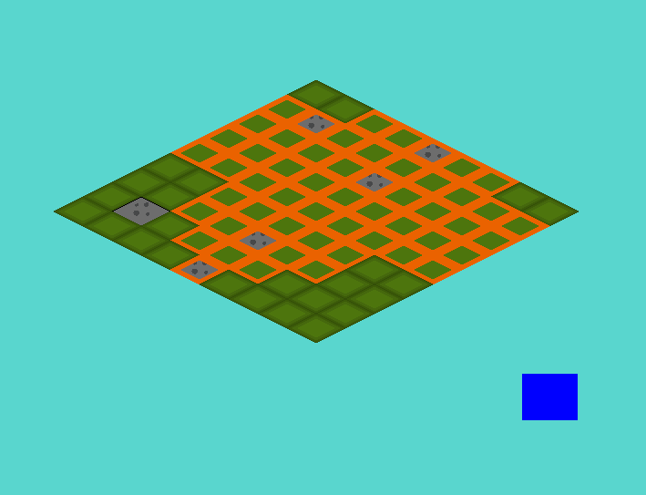Essentially what happens is the following; the moving unit gets moved to every space on the field; when moved there, the program first checks whether the unit can actually move there (if it’s within movement range, if the spot isn’t an obstacle or a different unit, etc). For every position it can move to, it checks all the fields it could possibly attack from that position. Doing this, for a ranged unit for example, we get the following grid;

For this I used a new function which checks whether a unit can move to a given tile, based on its movement pattern (aerial, grounded or naval units). The code for this is found below.

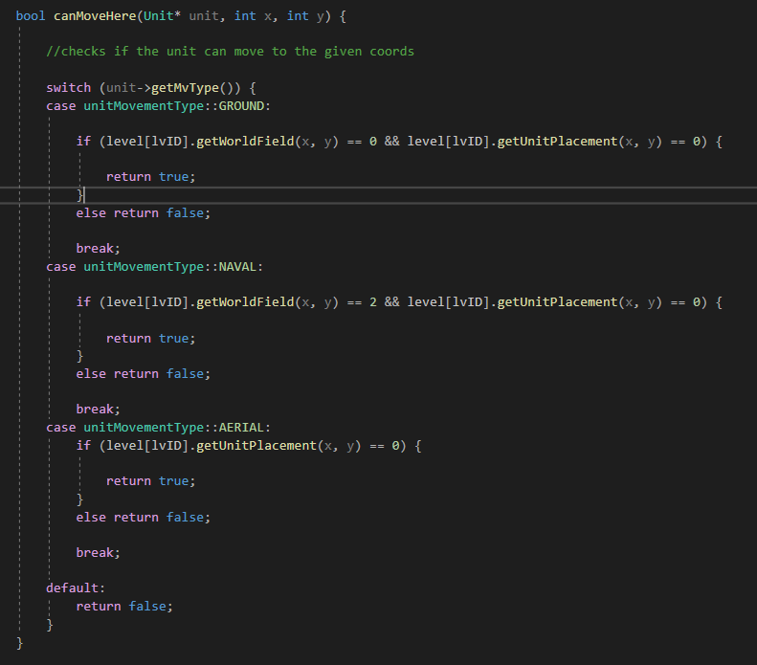

## Development- 19/02/2021

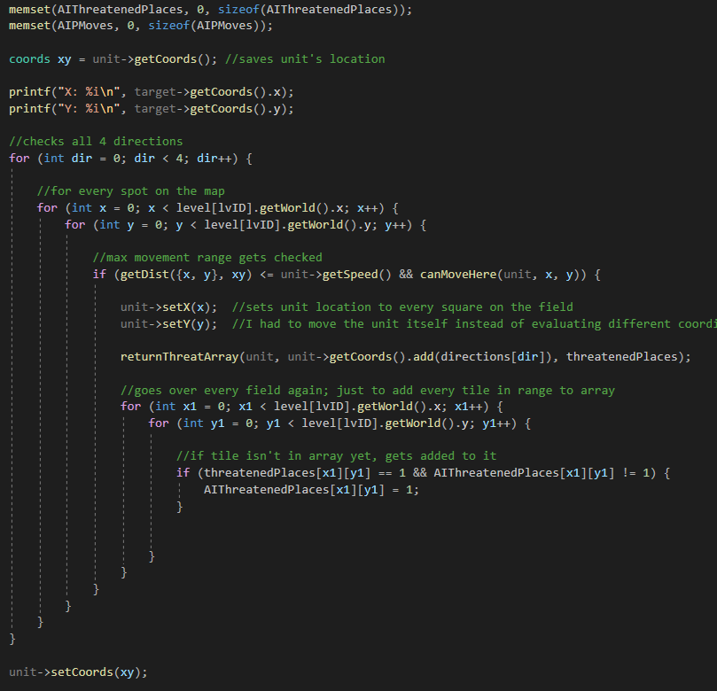

I made some updates for the AI; while the code below looks similar to the code shown yesterday, a few modifications have been made. The main one being; the code for generating the array consisting of every single possible field the unit can attack and the function used to generate all tiles the unit could move to have been split up into 2 different functions, one of them being the one seen to the right here. This was done because, for the targeting, I needed the attack array on its own, rather than the array of possible moves the AI could make.

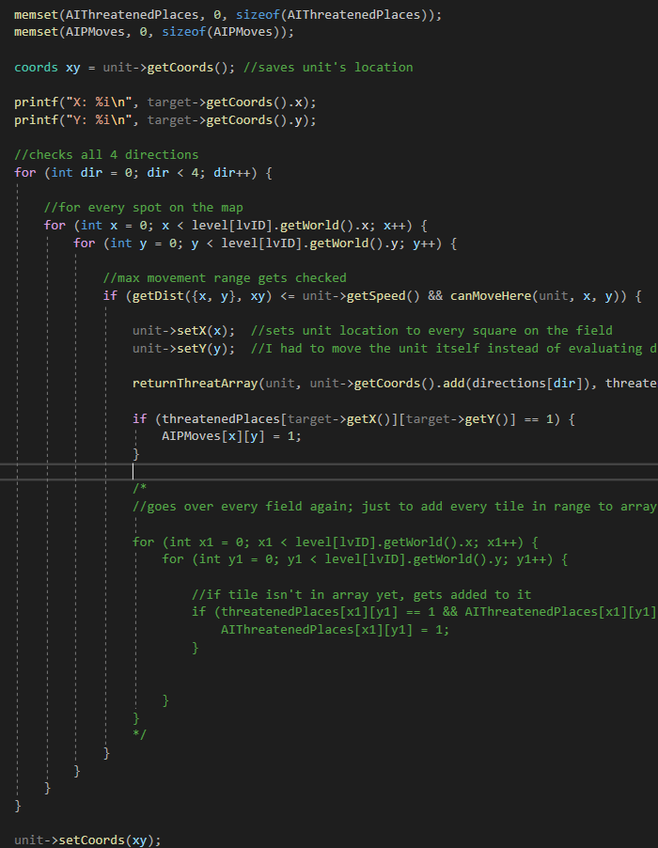To the left is the second function, the one which actually generates the array consisting of the AI’s possible moves. As you can see, it uses the returnThreatArray function (the other function, displayed above), and continues like how it used to be before the function was split up.

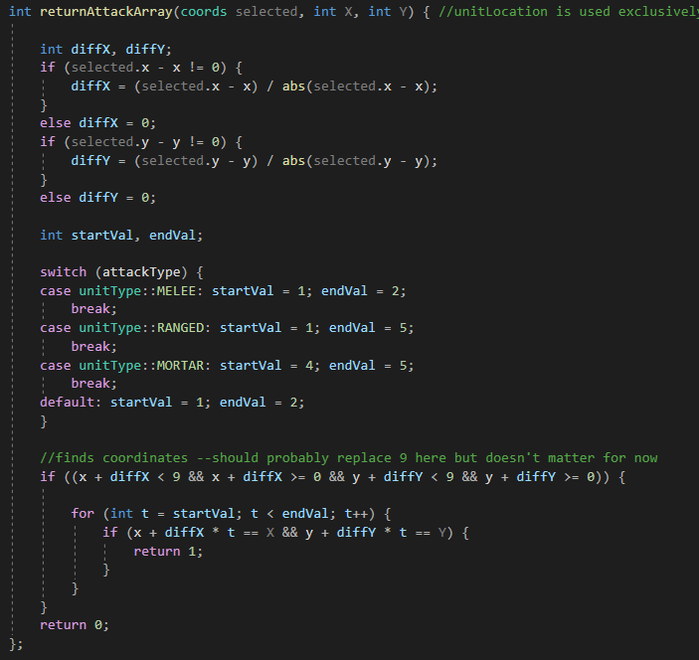Additionally, I fixed a bug which caused the unitType of a unit to always go to the default in the function that gets the attack array, which would cause the pattern created to default to that of a melee pattern.

While working on the targeting, I noticed something was off about the movement code I was using. More specifically, the distance calculation. The problem that was occurring was that enemy units were able to target units in places they weren’t supposed to. Now, up until this point I had just used Pythagoras for the distance calculation, but this gave a more rounded max range for units. I hadn’t encountered any issues with it up until this point because the friendly units the player controls don’t actively use this to check their maximum range, due to the way their movement works.

However, for the AI, the distance calculation was pretty important, so I ended up rewriting the distance calculation entirely to something which is a lot longer code-wise, and a lot less efficient. But, this gave me the correct results, so I kept this as is.

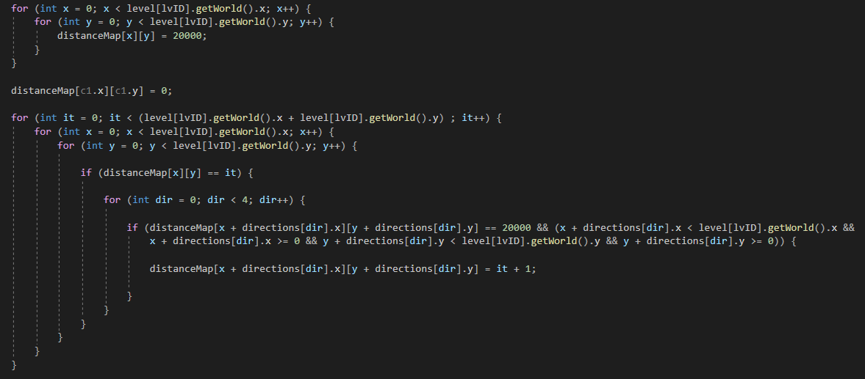

Below is a visualization of the problem;



On the left is the new solution, on the right was the solution using Pythagoras. (This was largely because of the faulty rounding that was being done, which made it seem rounder in the end).

In addition to this, I added another thing; now, when calculating distance, based on the unit’s movement pattern (grounded, aerial, or naval) it blocks out certain pieces of terrain, by setting their distance to 20000. 20000 is just an arbitrary number, but them being set to 20000 ensures that they can’t reach it, as it’s always out of range. The updated code for this is found below.

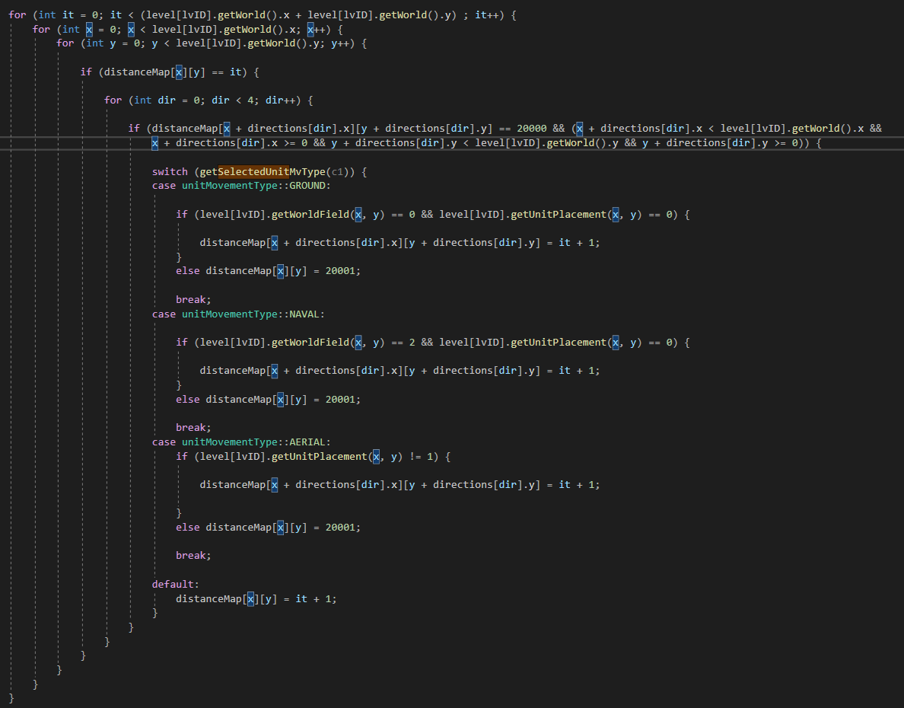

## Development- 21/02/2021

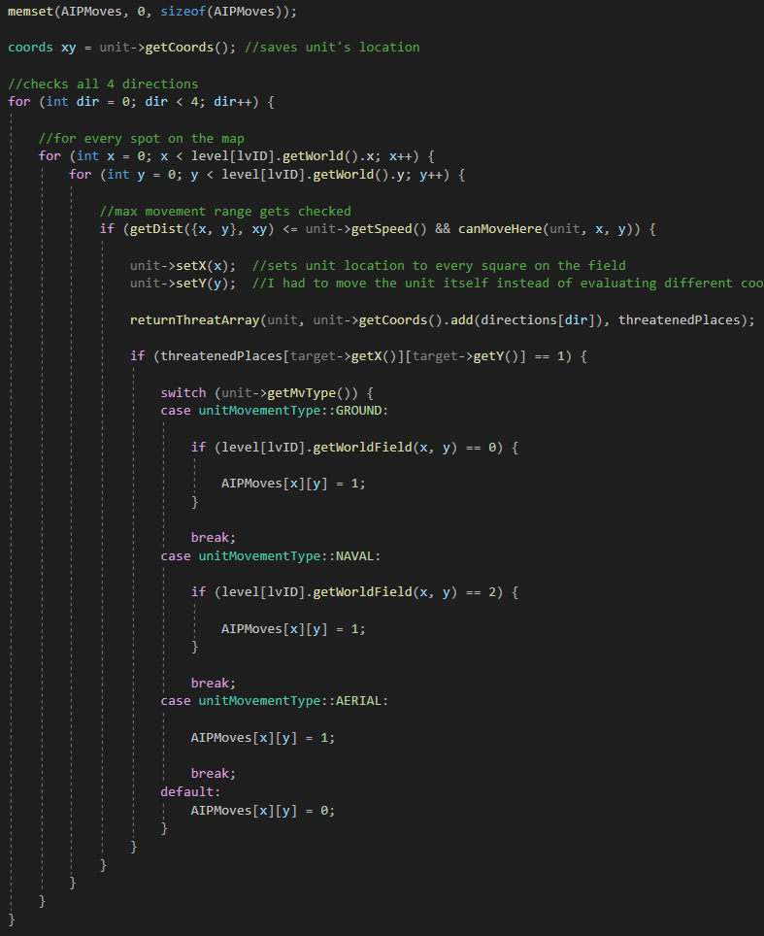

I added a switch statement to the code which checks what places the unit could possibly move to, to make sure that the fields the units couldn’t make any ineligible moves.

And when testing this by indicating every tile the unit could move to; it works. (The stone tile on the right is the unit attacking, the one on the left is the one being attacked, and the orange tiles are the tiles the unit on the right could move to in order to attack the left unit)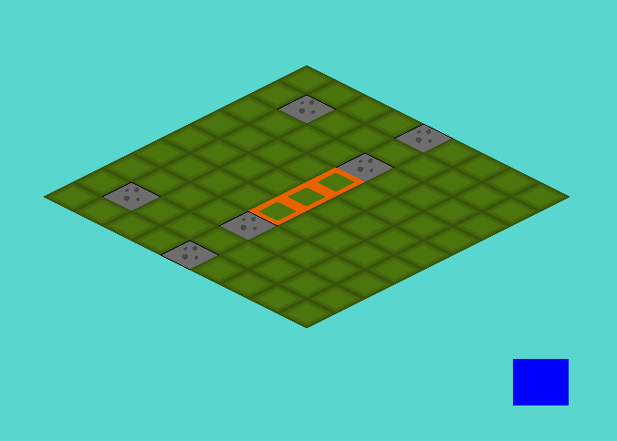

Below is my first attempt at making the pathfinding algorithm. It’s pretty simple; it starts out with 2 elements, the starting coordinates and the destination coordinates. It then checks every square around the starting coordinates, looking for which is the closest to the destination coordinates. It then moves the enemy unit to the closest square, and repeats this process until the unit is at its destination.

There is, however, a problem; it doesn’t account for all possible routes, rather it forms a direct route to the target, ignoring the terrain tiles. Which, for now, isn’t that big of a problem, it just means some routes will be blocked off.

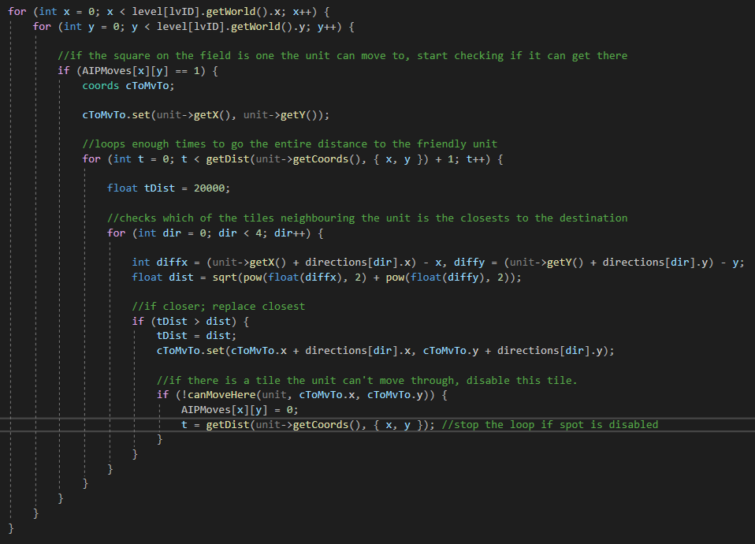

## Development- 22/02/2021

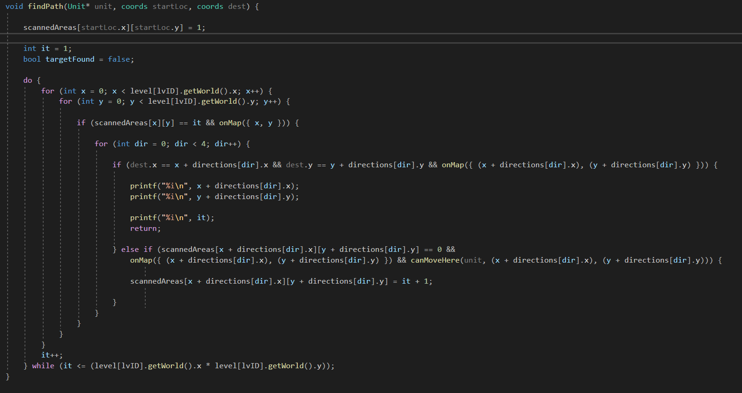

I wanted to change pathfinding algorithm today, as the previous iteration was causing problems with testing. So I did some research, and found a good video1 talking about pathfinding algorithms; 2 were detailed in the video, of which I chose the second one. The one I opted to choose to make worked like this; the algorithm starts out with 2 variables; the starting coordinates and the destination coordinates. The algorithm starts out checking every tile around the starting coordinates, if possible. The AI then loops over the entire map again, but instead of starting from the starting coordinates, the AI checks around every tile that was checked in the last iteration. This way it expands along the entire map, even around corners and around walls. While I haven’t implemented the units moving yet, having the system just log the coordinates for testing purposes, this will be coming soon. But for today’s session, I’m happy with this.

### Sources

1Youtube video regarding the pathfinding algorithms.

<https://youtu.be/KiCBXu4P-2Y>

## Development- 23/02/2021

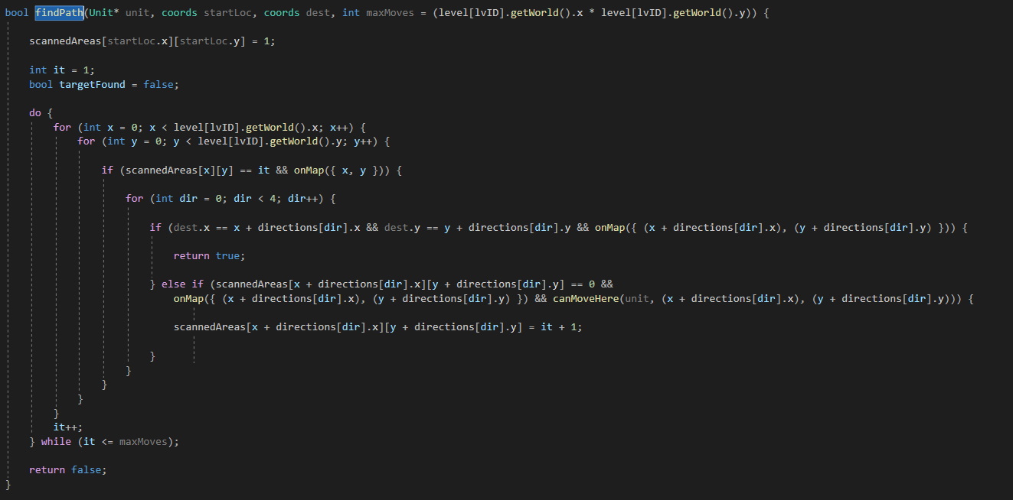

Above is the pathfinding algorithm updated again; I turned the function into a Boolean function, returning true if the unit is capable of reaching its destination within its given movement speed, and false if it can’t. This way, I can use this function both as a way to calculate the path the unit should take, and as a way of checking whether a unit can reach a certain spot within its movement speed. I’m honestly really proud of this, it makes this piece of code much more versatile, which means I don’t have to copy paste the code, in the process cluttering it.

Aside from this, I added the following piece of code to the function which determines whether a unit can move to a location or not.

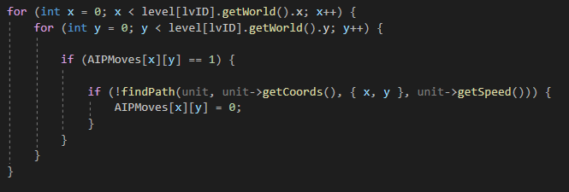

What this piece of code does is pretty simple; it checks the entire array of possible moves again, using the pathfinding algorithm to check whether the unit can actually move to these locations, and subsequently removing them if they can’t. This way, the amount of possible fields gets reduced and now only consists of tiles the player can actually move to in its turn. Some examples of what this piece of code does:

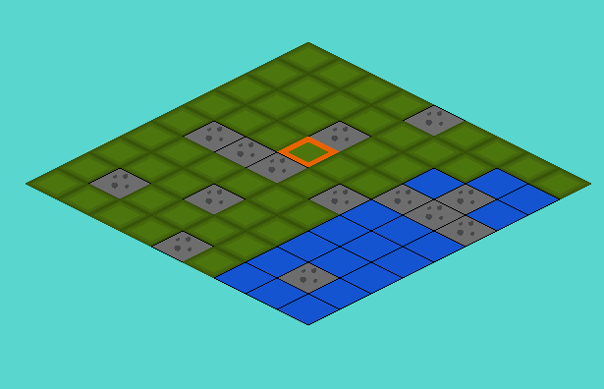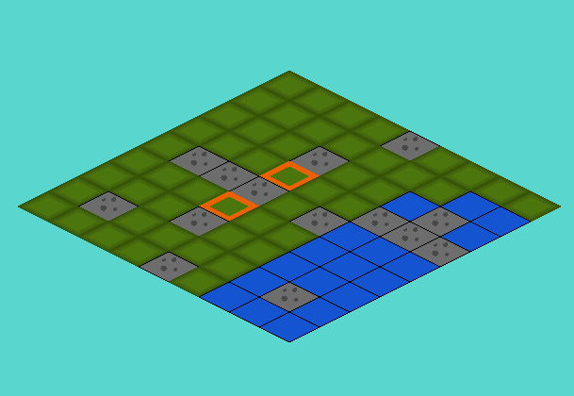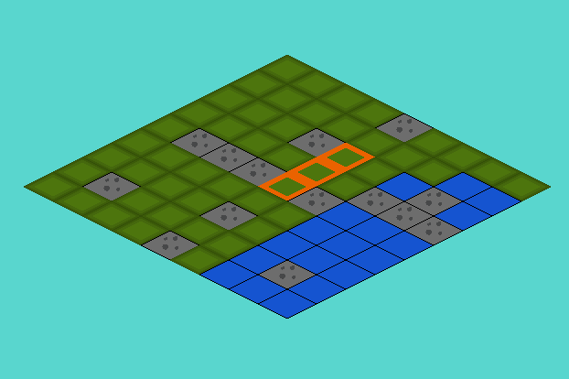With it on, without any walls that could be obstructing the unit

With this additional bit of code removed, the unit passes right through the wall

With this bit of code turned back on, now with a wall tile which obstructs it; can’t reach it anymore

Now, I only have to store the path the unit uses to reach its destination, then clean up the targeting code and then have the units actually attack the friendly units, and my game will be functionally completed.

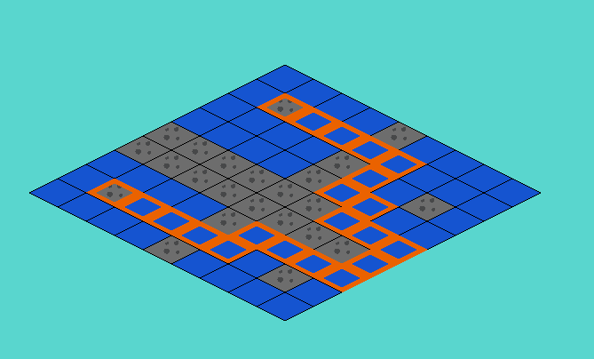

Picture of the pathfinding algorithm with the maximum distance turned off.

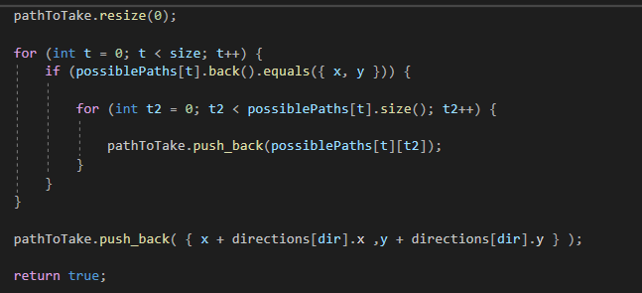Using std::vector I created a 2D array which contains every possible route a unit could take on the field. In the pathfinding code, I first check a tile and every neighbour after. When the neighbours are being set, I can compare the current tile (which would be in the middle of its neighbours and would coincidentally be the last place the unit has moved to) to the last value in the array. If the last value in the array is equal to the coordinates of the middle tile, meaning that the unit has been there, it creates another set of arrays comprising of every possible move it can take from there. This way I log every single possible combination of movement. When the destination is reached, I copy the single array of coordinates that comprise a unit’s path to a different array so I don’t have to keep all the other paths stored.

Above is the bit of code which saves the path the unit should take. possiblePaths is a 2D vector array which stores all possible paths (adding coordinates to existing paths and creating new paths whenever a different tile is checked), being saved to the pathToTake array. The pathToTake array is the path the unit has to take to reach its destination.

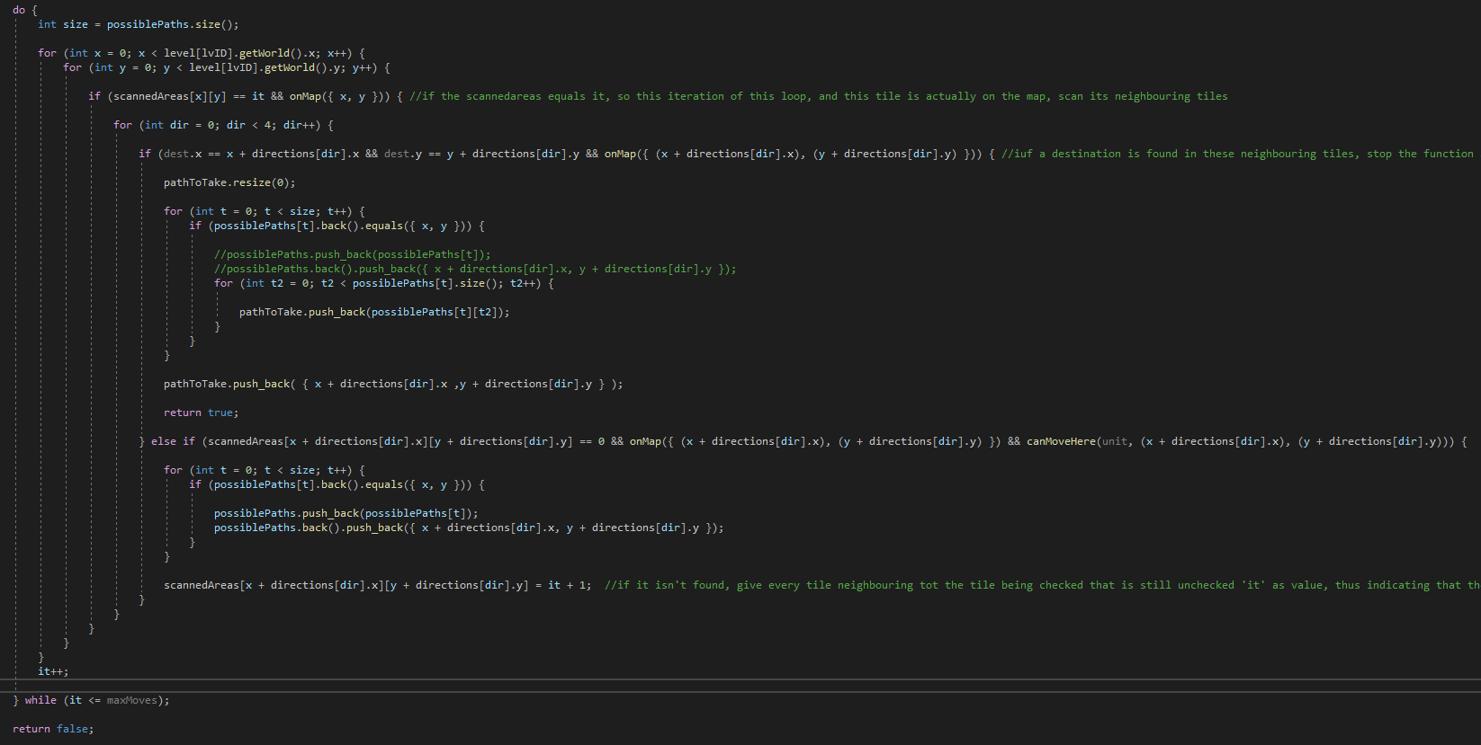

The full pathfinding algorithm

### Sources

<https://stackoverflow.com/questions/42249303/how-can-i-push-back-data-in-a-2d-vector-of-type-int>

<https://stackoverflow.com/questions/41325425/multidimensional-vectors-in-c/41325471>

<http://www.cplusplus.com/reference/vector/vector/>

<https://www.cplusplus.com/forum/general/197176/>

## Development- 26/02/2021

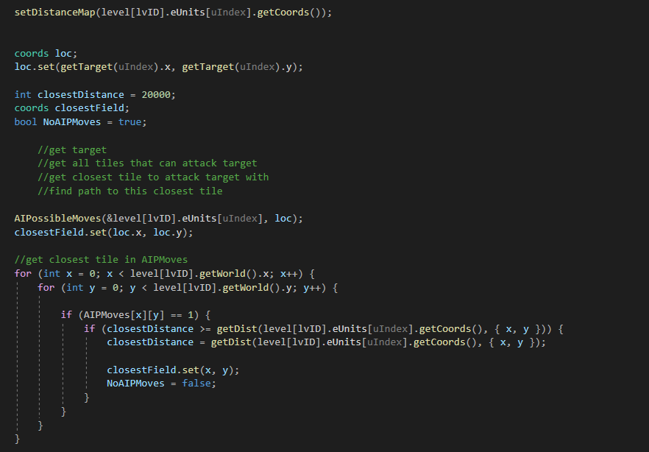

Now it was time to combine the separate elements of the AI (the target selection and the pathfinding) together. Firs the ‘loc’ variable is set to the enemy unit (with the getTarget function which chooses a unit as a target)

After this the program calculates all possible tiles the unit can move to in order to attack the newly selected target, and finds the one that’s the closest to the moving unit. If no tiles are available, the unit moves to the closest tile to the target in reach. In case the closest tile is one occupied by a unit or an objective, the target is set to a random tile neighboring it.

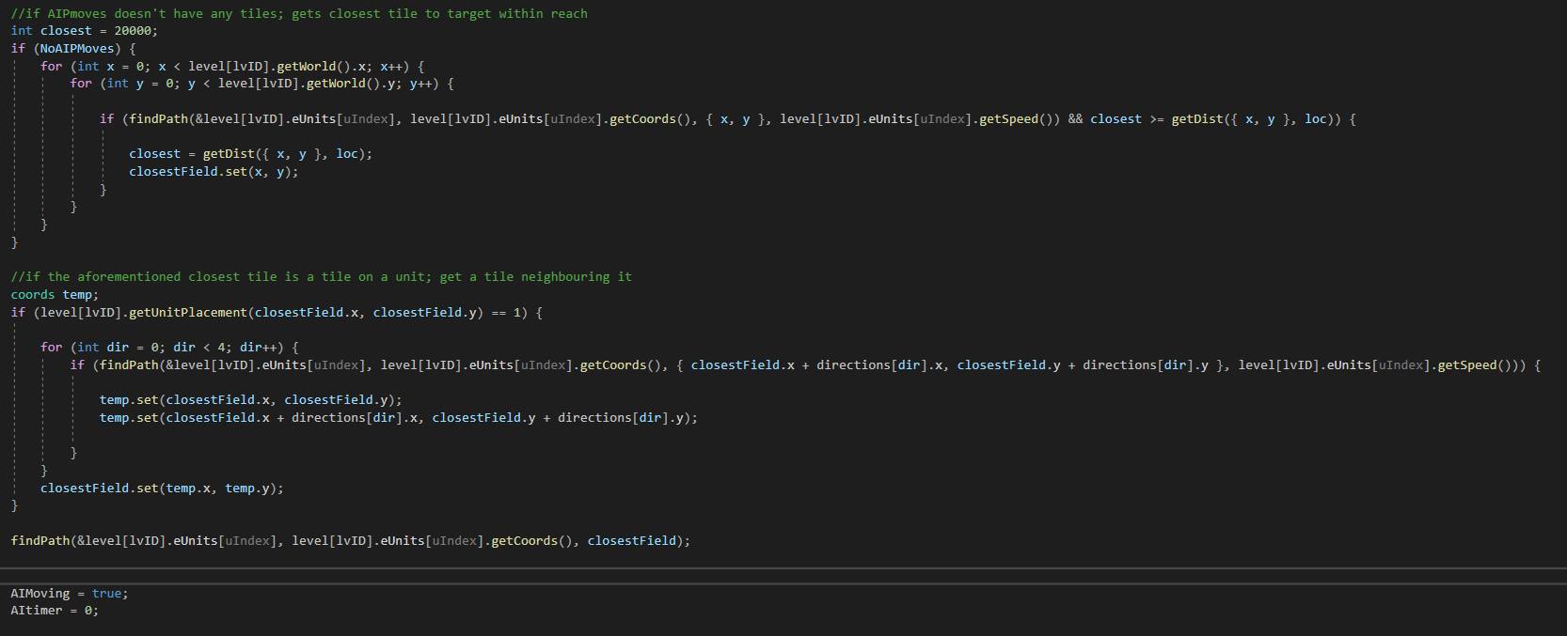

## Development- 28/02/2021

Finally, I added the AI to the flow of the game. In the gametick function, I added this piece of code:

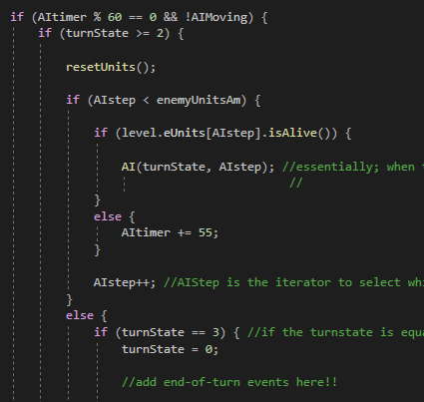

This piece of code is responsible for calling the AI function, which manages the entire AI. Every 60 ticks (1 second) it checks whether it’s the enemy’s turn or not; if it is, the code is activated for every enemy unit alive, after which the variable turnstate is incremented by 1, starting off the enemy’s attacking phase.

After testing it, a lot of bugs showed their nasty little heads. bugs concerning mistargeting, bugs regarding the pathfinding, etc. The main problem that caused most of these bugs was the targeting code; it would often return faulty values and errors, which would result in the pathing being incorrect. So, I changed around the targeting a whole bunch; first thing I did was simplify the targeting. It was incredibly cluttered, with a lot of full if statements which were basically incomprehensible. Below is the updated code;

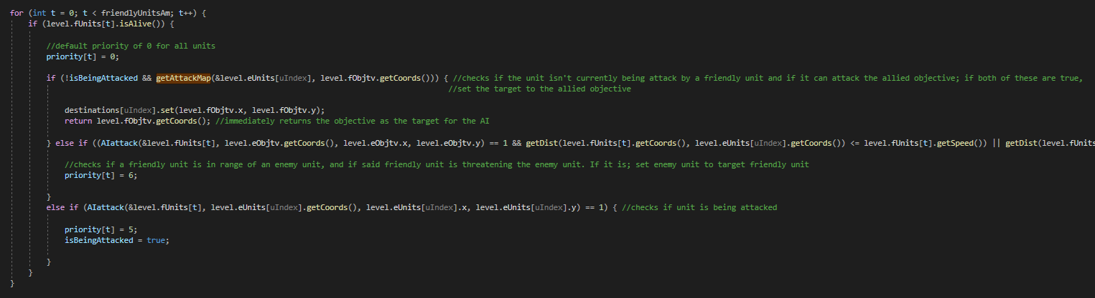

As you can see, the targeting is simplified a whole bunch; now it checks for only two conditions; whether the unit is targeting the objective, or whether a unit is threatening another unit. If both of these conditions aren’t met, the closest unit is targeted.

## Development- 01/03/2021

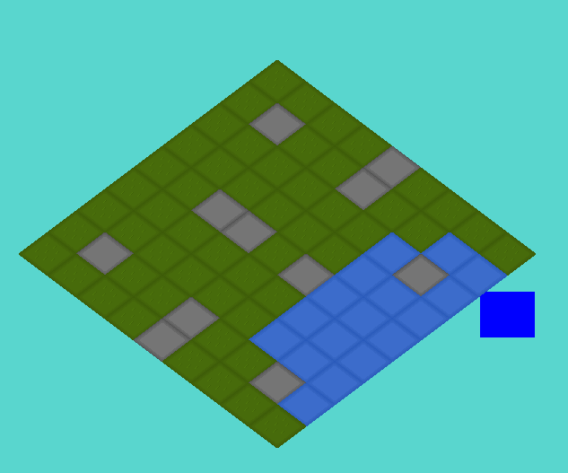Now that everything was working properly gameplay-wise, I thought it’d be a good time to do a little pixel art work. First things first I wanted to change around the tile size, which was pretty easy, although it took me some time to figure out and I made a bunch of funny looking mistakes, which you can see down below.

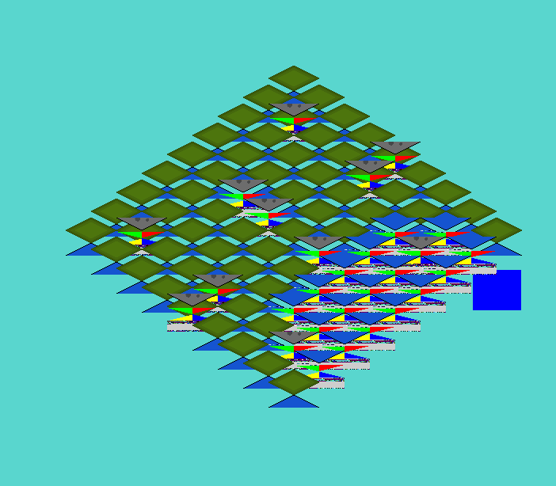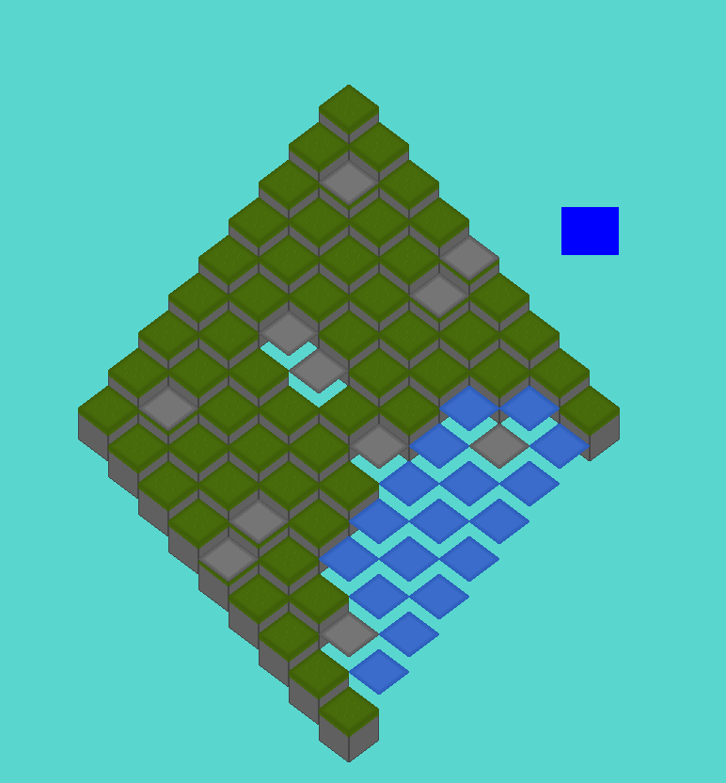

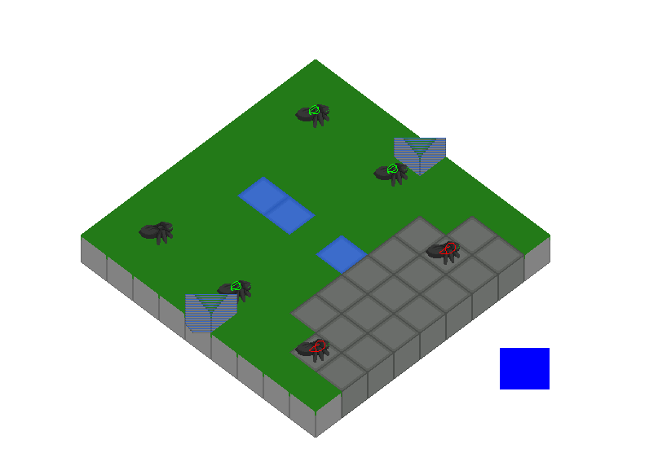

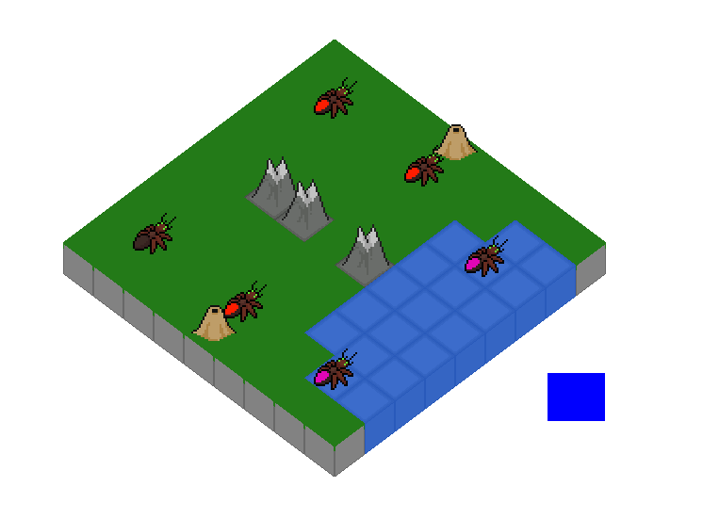

Above is the temporary design I went with for the tiles and the ants. Admittedly, I didn’t put too much effort into making things look nice, as it’s not really necessary in the context of this project.

## Development- 12/03/2021

I dug a little deeper into the topic of private and public attributes. You see, I was looking at the code I currently had, which used private attributes for everything, and had been for some time, and I asked myself; if the attributes has an accessor and a mutator, a getter and setter, anyways, then what is the point of keeping them private? I did some googling around on this topic and found that it was a highly debated topic. I assumed private was better due to my experience with writing in java, where making every attribute private is pretty much obligatory, lest the OOP purists on stackoverflow will yell at you, but I ended up finding a pretty interesting paper about this1.

The paper I read essentially laid out what the distinction between private and public fields should be, and I eventually came to agree with the notion provided in said paper; it explained how, when creating an attribute, if it’s an attribute that’s solely responsible of working with the inner mechanisms of the class, it should be private. E.g.: a variable which changes based on another variable that gets passed into the constructor, which might only have an accessor method but no mutator method. So, coming to this conclusion, I painstakingly went through the trouble of changing around every single private attribute which had both an accessor and a mutator to public fields. Needless to say, this process was long, tedious and overall not fun.

Additionally, I started playing around with the menu, and made some simple buttons (using the same method as I’ve been using for the button to skip turns, by just drawing it onto the screen) which would take you a main menu. For this, I added an ‘inGame’ variable, which would check whether the player was in game or not, and which would display a menu if they weren’t.

### Reflection

It’s been a long time again; I was again very busy with school and exams. Alongside this, I now have a job which is also taking in some of my time, so I really haven’t been able to work on this as much as I ideally would’ve wanted to. But I’ll attempt to work on the game more regularly from now on.

<http://www.idinews.com/quasiClass.pdf>

changed all variables that should be accessible to public fields, left all the others as private

## Development- 16/03/2021

Going off of what I’ve already written out code-wise, I added several arrays which would store the buttons the player would use to enter the levels. I ended up settling on 4 worlds, each containing 6 different levels for the player to play.

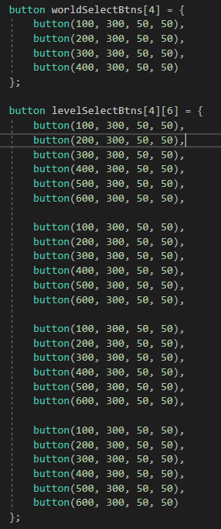

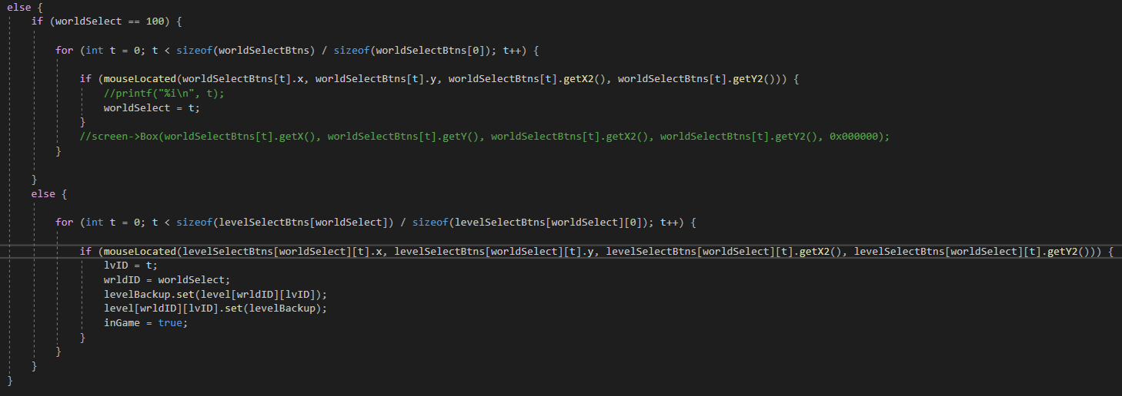

I added the worldSelect variable, which starts out at 100. If the player clicks one of the buttons indicating a certain world, worldSelect gets changed to the index of the button checked. The code above, when inGame is false, checks if the player clicks one of these buttons, and if a worldSelect button is clicked, they get transported to a level select screen (this is the else-statement). If a level is selected there, set lvID to the iterator value and set wrldID to the worldselectvalue to select a level.



I started toying around with how to load in multiple levels at once; at this point I was still working with large arrays of variables which would all be passed into one of 24 gameState objects to comprise the levels. This is a lot of memory used for something that really shouldn’t be taking up this much, so I opted to change it to something else. I thought to read the levels from a file; I looked around for a good source on how to use json files or any other data storing file, but nothing good came up. At least, nothing I was able to wrap my head around. So, I tried storing the variables myself, using regular C/C++ file reading to read out the file, then using string manipulation to extract the separate variables. This ended up not working at all, so I gave up on this for today, opting to work this out later on.

One additional thing I did however, I fixed a bug which had apparently been in the game for a long time. What would happen was, whenever a unit was killed, be it friendly or otherwise, their respective objective would disappear alongside them. This was caused by the way death was being handled; I teleported units off the map in order to kill them, which is how I avoided collision with killed units, which made the game bug out. Now they technically stay on the map, but they’re not counted in unitPlacement anymore and thus basically disappear.

### Sources

Stringmanipulation sources

<https://stackoverflow.com/questions/14265581/parse-split-a-string-in-c-using-string-delimiter-standard-c>

<https://www.fluentcpp.com/2017/04/21/how-to-split-a-string-in-c/>

<https://www.techiedelight.com/split-string-cpp-using-delimiter/>

parse string to int

<https://stackoverflow.com/questions/4442658/c-parse-int-from-string>

## Development- 17/03/2021

I didn’t do much today, however I added some neat planet pictures which I would use as my world select buttons. I added them on top of a background of a starry space, then did some quick editing to make it look as if you were looking at an old timey sci fi monitor, as seen below. Personally, I really like the effect it has.

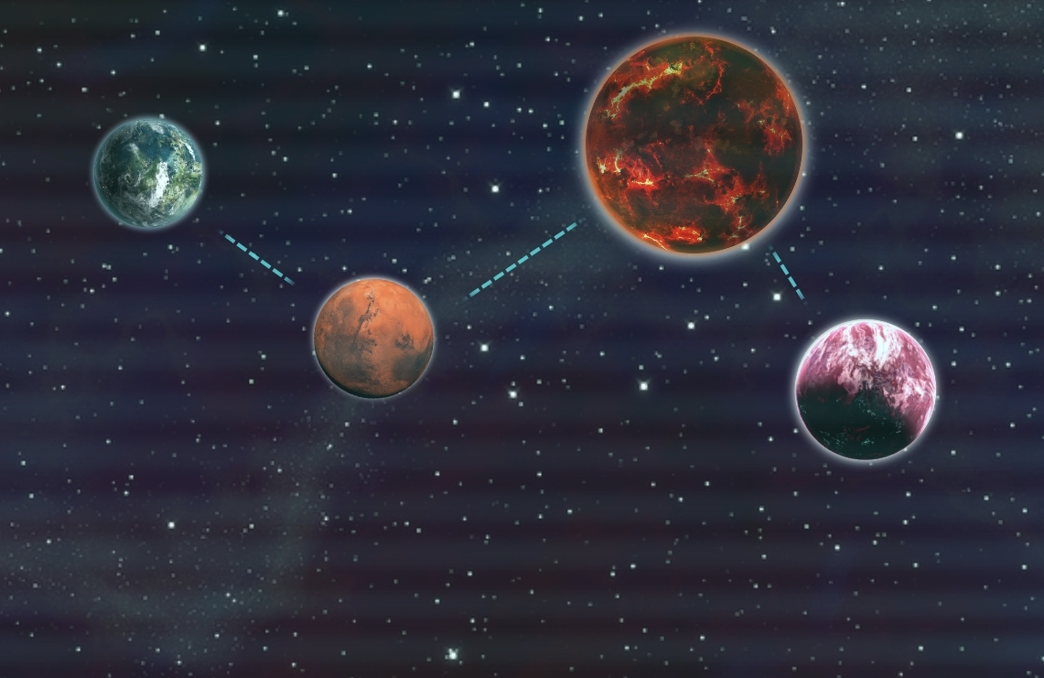

### Sources

<https://commons.wikimedia.org/wiki/File:Populated_Planet.png>

<https://pngimg.com/image/61161>

<https://pngio.com/images/png-a44054.html>

<https://commons.wikimedia.org/wiki/File:Lava_planet.png>

<https://blenderartists.org/t/space-background/660743>

## Development- 20/03/2021

I wanted to get some clean looking buttons, but didn’t quite feel like putting in the effort to sprite that much, so I went looking for a free sprite pack. Which I did find, luckily, namely I found: <https://free-game-assets.itch.io/free-tds-game-ui-pixel-art> which I quickly downloaded and recoloured to a colour which fit the aesthetic of the game better. So I added some cool looking buttons, which I’d use for the level select screen when a world was already selected.

Additionally, I drew up a character which would give you the tutorial, and added a dialogue box to accompany her. However, when drawing her onto the screen, I noticed the game had issues with rendering both transparent and black pixels, as it would completely remove both. My first solution was changing the colour of the linework on the character to a different colour than black, but this didn’t fix the problem with transparent pixels. Not that there were any largely transparent surfaces, but the linework got pretty messed up because of it.

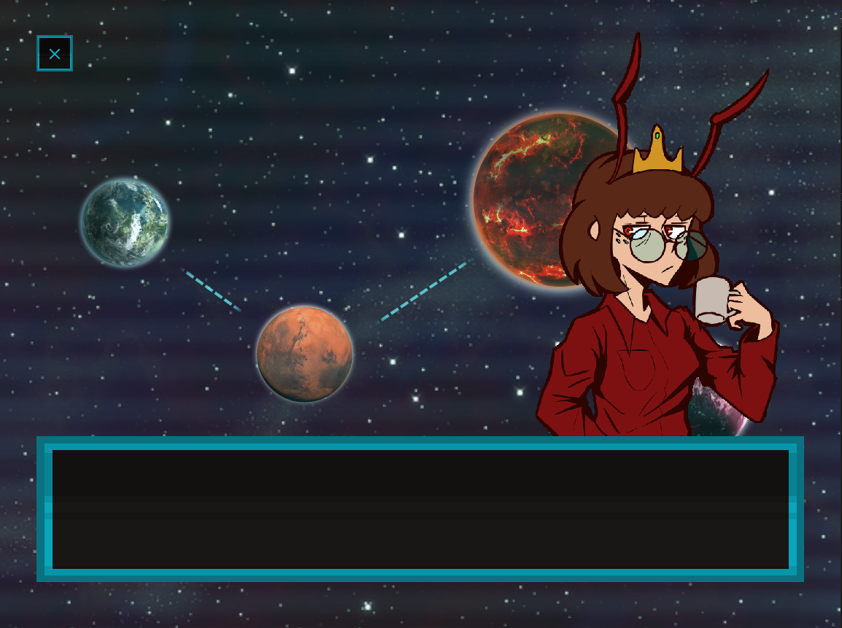

I tried figuring out what caused this, and found things regarding ADVANCEDGL. However, when I attempted to turn it on in the code, the following happened;



The entire screen became lighter and lighter, and kept doing so until the entirety of the screen was completely white. I honestly don’t know enough about OpenGL/graphics rendering to even know what the problem is, let alone how to fix it, so I just stopped working on the dialogue function all together for now.

I did, however, add bounds to the drawScaled function, as it was messing up with the sprite for the character. (it was supposed to come moving in from the side of the screen, which crashed the game before I made my edits to the rendering code).



### Sources

resources on pixel transparency when a sprite wasn’t loading properly;

<https://www.3dgep.com/cpp-fast-track-9-colours/>

<https://community.khronos.org/t/beginner-texture-transparency-problem/60994>

<https://www.youtube.com/watch?v=chbjxTmbQes>

<https://discuss.cocos2d-x.org/t/how-could-i-get-the-alpha-value-of-a-pixel-in-a-texture/4957/5>

## Development- 22/03/2021

I wanted to check out whether or not my game was efficient, as I imagined it wouldn’t be that efficient, and found something quite interesting; I had about 30fps when just sitting in the menu. This was interesting, as I imagined that, if I were to have bad performance, it would be because of the AI looping over the field several times. But no, while the AI doing its thing cost me around 3 frames whenever it happened, the menu itself cost me way more. So, after some experimenting (commenting out certain parts of the code until the fps got better), I noticed 2 things were significantly reducing the fps, namely; the background rendering and the piece of code that drew the sprites for the dialogue. The thing they both had in common was that both used the drawScaled function, and lo and behold, after changing it the fps went back to normal.

I tried rendering the background in a different way, namely through using memcpy, and while I believe it could have worked, I opted to instead just use the draw function which came with the template.

### Sources

<https://stackoverflow.com/questions/31673359/understanding-the-copy-done-by-memcpy>

<https://stackoverflow.com/questions/56514669/understanding-why-it-doesnt-copy-correctly-using-memcpy>

<https://stackoverflow.com/questions/9688454/cropping-an-area-from-bitmapdata-with-c-sharp/9691388>

<https://www.gamedev.net/forums/topic/694264-directx-9-with-c-how-can-i-draw-an-image-transparent/>

## Development- 03/04/2021

The biggest thing I wanted to still finish up about my game was the level loading, as it currently uses a lot more memory than it should be. So, I came up with the idea of storing it in files. However, I still didn’t have a clue as to how to actually do it; I attempted looking into json again, saving it in bin files, etc; but ended up finding a pretty good video1 which I could use to actually read from the files.

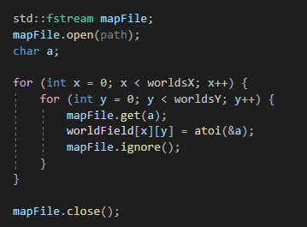

Using the code above, I was able to read out an 11x11 2D array which I could use as the layout for the map. However, this still left me with the problem of loading in units; I first tried loading these in before loading in the map, as separate variables, but this ended up being very tedious and unwieldy. So, I gave up for the day, as I already got it working and decided to have a think about how to properly handle this situation.

### Source

Reference for json, which I initially tried to use to read the files.

<https://www.w3schools.com/js/js_json_arrays.asp>

1<https://www.youtube.com/watch?v=P2LdhPpqSiU>

## Development- 05/04/2021

I finally figured it out; After about 2 days of thinking about how exactly to load the units and objectives, I came up with a solution which I’m pretty proud of; using the code I already had written down, which read out every symbol on every line, using a comma as a delimiter, I thought that maybe I could just write the units straight into this same system. So, I attempted it; now, when reading over the map, if it reads anything that isn’t a tile (in this case, if it reads a letter), according to that letter it generates a unit at that position.

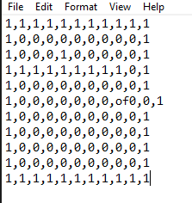

Above is a simple example, using a normal map (the numbers), but generating one objective, namely the ‘of’. (objective, friendly)

So I started writing the code, and in the end came up with a pretty good system; when the system finds a value that isn’t one of the tiles, it:

Checks if the char read is any of the following values:

-‘o’, for objective, after which it checks for an ‘f’ or an ‘e’, to indicate friendly or enemy objective

-‘u’, for unit, after which it checks for ‘f’ or ‘e’ in the same vein as with the units, after which it checks for either an ‘M’, an ‘m’, or an ‘r’ (melee, mortar or ranged), followed by an ‘n’, ‘g’ or ‘a’ for naval, grounded or aerial.

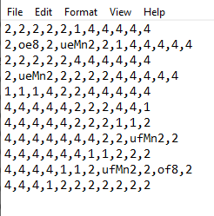

A more complicated example.

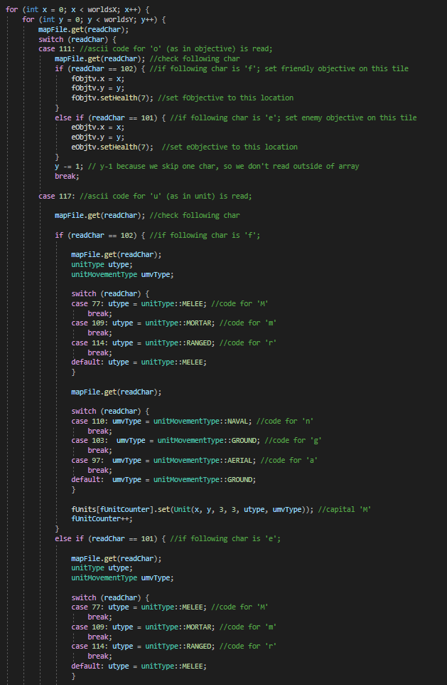

The code above is a screenshot of the finished code (at least the top part, but the bottom part continues in the same manner so I reasoned this would be sufficient for the explanation)

So, again; it reads the character, and based on that character either straight up adds the tile or adds a unit/objective on top of that. I’m really proud of this system, and although the code is pretty dirty with all those switch statements, I think it’s a pretty decent solution to an otherwise pretty annoying to solve problem. Using this system, instead of storing an array of gameStates, I changed it to load in a single gameState, which loads whatever level the player clicks on the moment the player selects the level. In doing so, the amount of memory used by storing the levels is drastically reduced. I ended up being really happy with how this all worked out, and while I can imagine there’s still ways to optimize this, I’m happy with how clean and efficient it ended up being.

## Development- 06/04/2021

I wanted to finished the game by now, so I went to work; I first added a menu to the right, which displays the attack pattern of selected units, no matter if they’re allied or enemy units. This way the player could always know what type of enemies they’re up against.

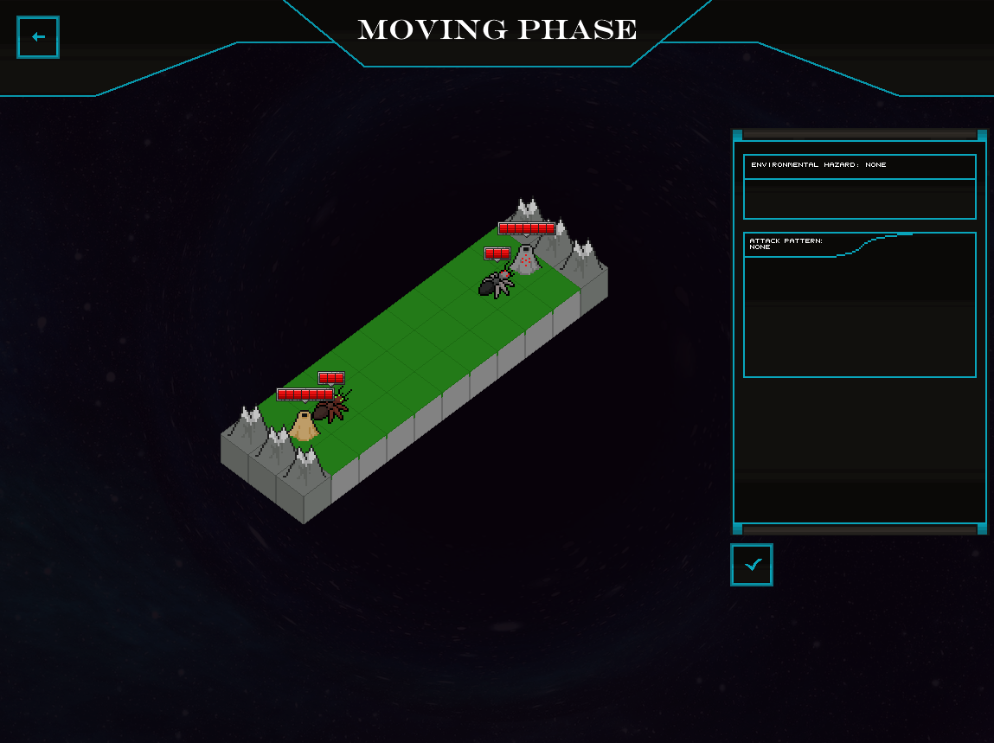

Alongside this, in the same menu, I added a section for the level hazards; these were small effects which would influence the game, based on what world the player is in (e.g.: dealing 1 damage to all units, healing every unit 1 health, etc). Seeing as the AI already automatically finished its turn and started the player’s turn, it was pretty easy to just add them there.

Another thing you can see in the picture above is the health bars; this is pretty simple, it’s just a sprite with a different texture for each health. In unity, I remember adding a bar which would scale to represent the health, and while it would probably be more efficient doing it like that, this was easier and seemed to work just the same.

I also changed the textures of the enemies to metallic ants; I originally wanted to make different textures for each world, but I ended up just doing this as I didn’t feel like spending all that time spriting different textures for enemies for all the different worlds, so I just recolored the ants and called it a day.

I also scrapped the dialogue; it’d have been nice to implement, but I deemed it unnecessary. Maybe in the future I’ll add it back in, but for now it’s staying like this.

When all that was said and done, the only thing left for me to do was create some levels; which I did. I spent hours writing up 24 different levels. I’ll admit; I haven’t played all of them. I designed these fairly quickly, as I kind of just wanted this project to be done at this point. I feel like I’ve worked for far too long on a project that should’ve been pretty simple, so I wanted to just finish everything up. But, just for good measure, here’s some pictures of some of the finished levels, from various worlds.

I ended up being able to accomplish much in terms of different level designs; I added a bunch more tiles, most importantly: empty tiles and lava tiles. Lava tiles would damage all units standing on them at the end of the turn, while empty tiles are just that; tiles completely void of any properties, not accessible by any unit. Using empty tiles cleverly, I was able to change the shape of the levels from just a boring 11x11 grid to any shape within said grid, as you can see below.

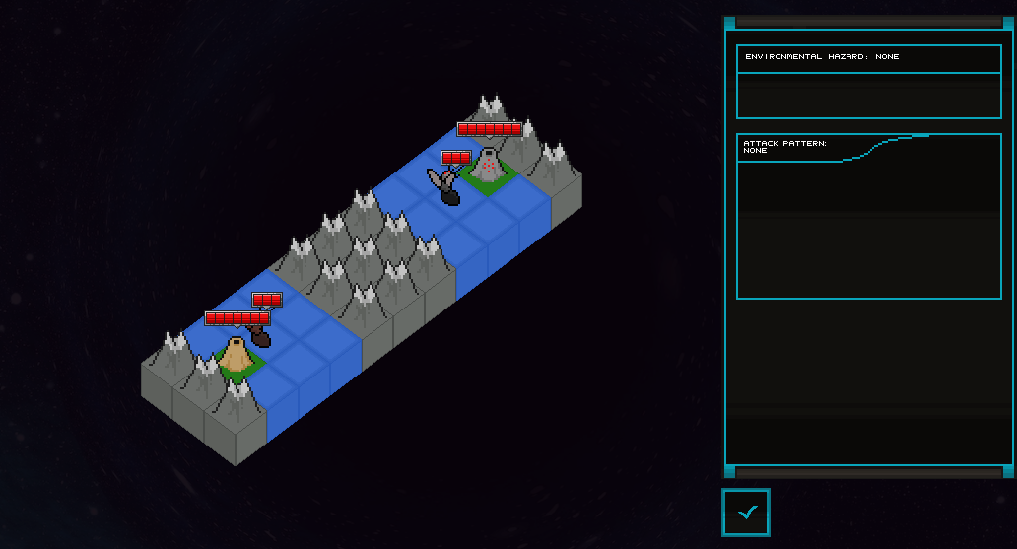

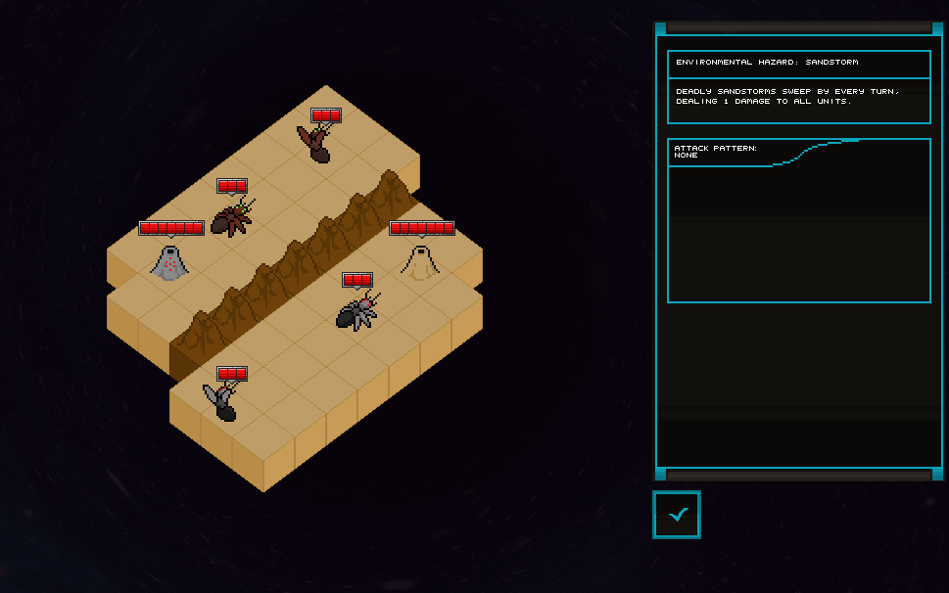

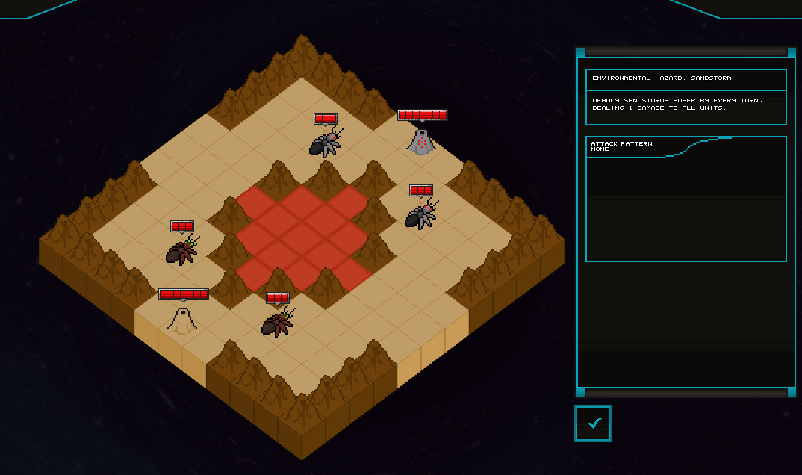

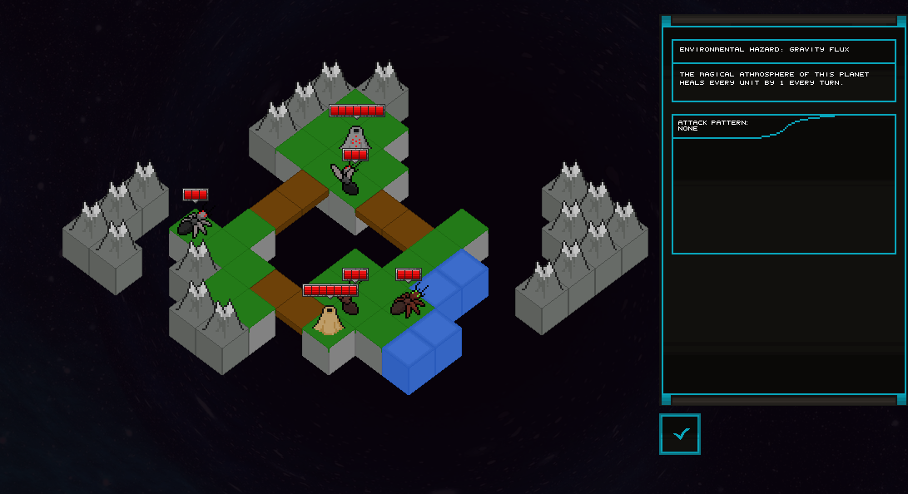

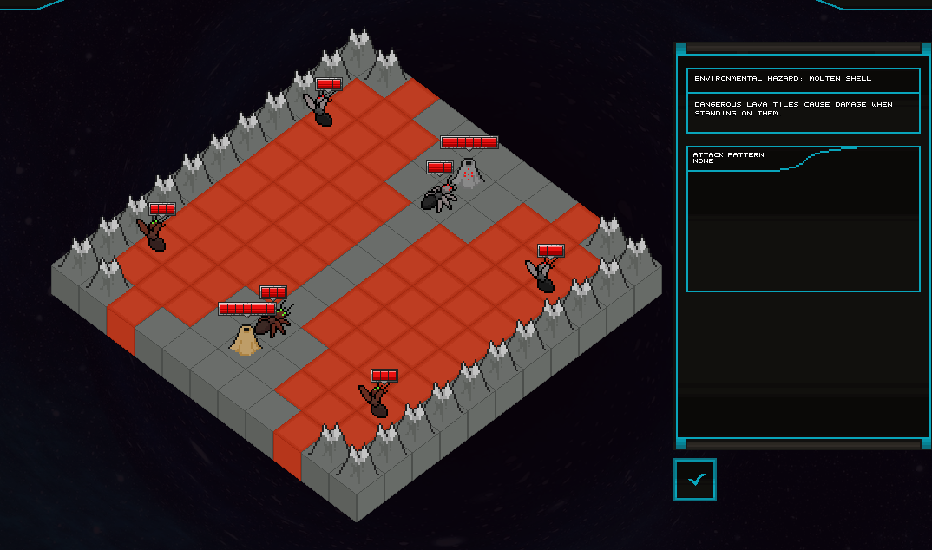

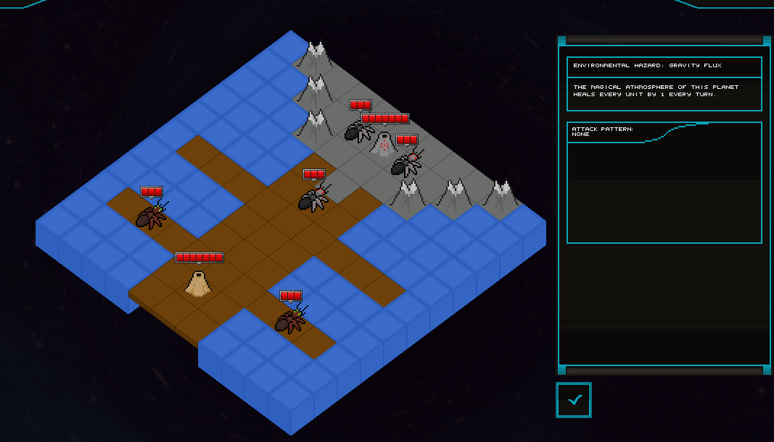

## Finished game- review

I ended up really liking the little game I came up with. Admittedly, it’s got a lot of flaws. The gameplay isn’t all that solid from a design perspective, it doesn’t look great visually, it’s got no real pause menu, no system to pause the game, etc. All things I wanted to implement at some point, but I got really busy with work and school near the end, which resulted in me calling the game finished and leaving it at what it is. That being said though; I’m really quite proud of the pathfinding algorithm and the level loading.

In the very beginning I made some hypotheses about how the project would go, establishing some in scope and out of scope goals, alongside laying out difficulties I thought to find along the way. I will go through every one of these, and comment on it now the game is finished.

### In-scope goals:

**-Isometric turn-based strategy game, where you compete against an AI controlled enemy.**   
This one I essentially had to finish, because this is the basis of the game itself.

**-You control various units, different fighters, scouts, and a queen which can produce more units (up to a cap)**  
This one is pretty interesting; instead of a queen, I implemented the objective tiles, and instead of using a system like scouts and fighters I implemented different movement patterns and attack patterns. That being said though, the idea stayed the same.

**-Different mission types: destroy cities, capture objectives, destroy all enemy units, etc**  
This actually surprised me when I read this back; I had totally forgotten that this was one of the in scope goals I wrote for this project. I didn’t get to implement this, which is a shame, but not the biggest problem in the world.

### Out-of-scope goals:

**-Different types of enemy factions, which all have different powers and pose different challenges to the player**  
This one I did actually implement; although not as in detail as I wanted it to be. I wanted to create a whole fantasy universe with characters, but ended up scrapping most of that.

**-Upgrades to the player’s units, or different units the player can select. (different types of ants, long ranged ants vs melee ants, etc)**  
This one I didn’t implement at all, which is pretty sad, but then again; this might’ve brought me too close to the border between inspired by and ripping off Into the Breach.

**-Randomly generated challenge, where you face off against a randomly generated map of enemies for rewards.**  
This one, again, I didn’t implement at all. Looking back, I know how I’d implement this, probably using noise on an image and downscaling it, but that would’ve been very complicated and this was definitely a reasonable out of scope goal.

### Expected Difficulties

**-Usage of C++. I’m personally more used to higher-level programming languages, such as javascript or java, so adopting C++ is going to be a bit of a struggle.**  
While I’d used C++ before, it definitely wasn’t my strong suit when starting this project. Now, about half a year later, and I love the language. It was a bit of a learning curve, but I think I managed to get there in the end.

**-Implementing the enemy AI. I have never really tackled AI before (or at least not written one myself), so this will be quite difficult. I’m expecting this to be my biggest hurdle, but we’ll see.**  
This one was pretty difficult, but also really fun and exciting to work on. While calling it an AI might be a bit presumptuous, I’m really happy with how it turned out.

All in all; this was a really fun project, and even if I don’t get into BUas, I’m glad I had the experience and will definitely continue to make games. Even if I don’t get in, I’ll keep working on various hobby games by myself, and will probably end up working in the industry anyways.